**PRACTICAL FILE**

**BE (CSE) 3rd Semester**

**DATABASE MANAGEMENT SYSTEM**

**July 2023 – December 2023**

**Submitted By**

**Name: Jatin Dhiman**

**Roll Number: UE223047**

**Submitted To**

**Dr. Mamta Juneja**

**Professor, Computer Science and Engineering**



**Computer Science and Engineering**

**University Institute of Engineering and Technology**

**Panjab University, Chandigarh – 160014, INDIA**

**2023**

# INDEX

|  |  |  |  |
| --- | --- | --- | --- |
| PRACTICAL NO | Content | dates | Page No |
| 1 | Introduction to SQL:   1. **Types of SQL commands:**   DDL : Create, Rename, Alter, Describe, Truncate  DML : Insert, Update, Delete, Select   1. **Use of CREATE AS, USER_CONSTRAINTS,TAB, SPOOL ON**   **\* EXECUTION OF ALL ABOVE ON STUDENT MANAGEMENT SYSTEM** |  |  |
| 2 | Data Constraints and its types: **A. Naming of a Constraint**   * **Types of Constraints: Column level, Table level**   1. Primary key   2. Foreign key   3. Unique   4. Not Null   5. Check   6. Default * **Behaviours of foreign key table:** * On delete/Update Restrict * On delete/Update Cascade * On delete/Update Set Null * **Integrity constraints via Alter Table command**   **\* EXECUTION OF ALL ABOVE ON STUDENT MANAGEMENT SYSTEM** |  |  |
| 3 | 1. **Data Control Language (DCL)**    1. Grant    2. Revoke 2. **Transaction Control Language (TCL)**    1. Grant    2. Revoke   **\* EXECUTION OF ALL ABOVE ON STUDENT MANAGEMENT SYSTEM** |  |  |
| 4 | SQL Operators and functions: **A. 1.Operators:**  a)Arithmetic  b)Logical  c)Relational  **B. 2. Functions:** |  |  |

|  |  |  |  |  |  |
| --- | --- | --- | --- | --- | --- |
|  | a)String functions  b)Numeric functions  c)Aggregate functions  d)Date functions | | |  |  |
| 5 | Order By, Group by and Having statements | | |  |  |
|  | **Apply on queries 1 to queries 16 in Annexure 1** |  |
| 6 | Subqueries   1. Nested queries ( Single row, Multi row) 2. Correlated queries | | |  |  |
|  | **Apply on queries 1 to queries 16 in Annexure 1** |  |
| 7 | Joins:   1. Cross Join 2. Natural Join 3. Inner Join 4. Outer Join(left ,right and full) | | |  |  |
|  | **Apply on queries 1 to queries 16 in Annexure 1** |  |
| 8 | Views   1. Introduction 2. Types: Materialised and View Resolution 3. Features/Advantages 4. CREATE, DROP VIEW( using single table, Multiple Tables 5. INSERT UPDATE DELETE IN VIEWS | | |  |  |
|  | **Demonstrate on database created in Practical 1** |  |
| 9 | Indexes   1. Introduction 2. Types: Unique, Duplicate, simple, Composite 3. CREATE, DROP INDEX ( on single column, multiple columns) | | |  |  |
|  | **Demonstrate on database created in Practical 1** |  |
| 10 | Sequence   1. Introduction 2. CREATE, DROP SEQUENCE 3. USING SEQUENCE TO INSERT VALUES IN COLUMN OF A TABLE(ex employee id, student rollno etc) 4. ALTER SEQUENCE | | |  |  |
|  | **Demonstrate on database created in Practical 1** |  |

|  |  |  |  |  |  |  |  |  |  |  |
| --- | --- | --- | --- | --- | --- | --- | --- | --- | --- | --- |
| 11 | Introduction to PL/SQL A. Syntax of PL/SQL  B. Control structures in PL/SQL and their syntax  ( Sequential control, Conditional , Iterative)  P1: To check if a year is a leap or not .  P2: To find area and circumference of a circle using a case statement.  P3: To check whether a prime number or not using while loop and for loop  P4: To generate fibonacci series  P5: To generate factorial of a given number  P6: To Check Palindrome  P7: To create a dummy calculator taking two numbers as input as performing selected operation(Addition, subtraction, multiply, etc) and displaying output  P7: To display cgpa and grade  P8: Bubble sort  P9: Linear Search  P10: Binary search | | | | | | | |  |  |
| 12 | Subprograms in PL/SQL:   1. Introduction to Procedures Syntax of Procedures   Write procedure for P1 to P10   1. Introduction to Functions   Syntax of Functions  Write function for P1 to P10 | | | | | | | |  |  |
| 13 | Triggers in PL/SQL   1. Introduction to Triggers 2. Advantages and disadvantages of triggers 3. Syntax of Triggers 4. Types of Triggers Before event Triggers   After event Triggers  Row Trigger  Statement trigger  Hybrid Trigger   1. Write programs to demonstrate all types of trigger | | | | | | | |  |  |
| given in | | | D | on the database created in Practical 1 | | | |
| ( | | **Identify one real world project like Railway Reservation** | | | |  | |
|  | **system, University management system, Airline Reservation** | | | | | |  |
| **system, Hotel management system, library management** | | | | |  |
| **system , On-line shopping portal,Hospital management** | | | |  |

|  |  |  |  |  |  |  |  |  |  |
| --- | --- | --- | --- | --- | --- | --- | --- | --- | --- |
|  |  | | **system etc and Create a database comprising multiple tables** | | | |  |  |  |
| **while demonstrating)** |  | | |
|  | **F. Implement AUDIT TRAIL to keep record of every** | | | |  |
|  | **insert, update, delete on above database, it should** | | | |
| **store name of the user, operation performed and** | | |  |
| **time of the operation** | |  |
| 14. | Cursors in PL/SQL   1. Introduction 2. Advantages and Disadvantages of cursor 3. Types of cursors:Implicit and Explicit Cursors   Program:To count the number of records using an implicit cursor.  Program:To display records of 5 least paid employees using explicit cursor.  Program:To display records of 5 highest paid employees using explicit cursor.  Programs: To display functionality of %TYPE,  %ROWTYPE  Programs: Create IMPLICIT and EXPLICIT cursor to  demonstrate functionality of all 4 attributes for  PRACTICAL 1 DATABASE | | | | | |  | 2/11/2021-8/11/2 021 |  |
| 15 | Package in PL/SQL   1. Introduction to Package 2. Package SpecificationD 3. Package Body 4. ADVANTAGES and DISADVANTAGES 5. Create Package of Circle area and Circumference 6. Program: Create complete package for employee management system to demonstrate insert, update, delete , search(by name, id), diplay, calculate salary, increase salary, promote, demote employee records 7. Program: Create complete package for PRACTICAL 1   DATABASE | | | | | |  |  |  |
| 16 | Exception Handling   1. System defined Exception handling 2. User defined Exception handling 3. Write Programs to demonstrate A and B for the Package programs E to G | | | | | |  |  |  |

ANNEXURE1

**TABLE 1 : EMPLOYEE**

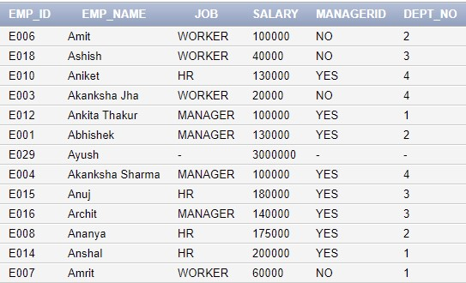

**TABLE 2 : DEPARTMENT**

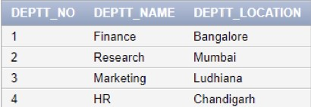

QUERY 1 : Give Total Salary issued by each Department

QUERY2 : Average salary of each job

QUERY3 : Give the total salary paid to each job within each Department

QUERY4 : Give Total, minimum, maximum and average salary of employees job wise for department numbers 1 and 2 and displaying rows having average salary > 1,00,000 QUERY5 : Give name, salary of employee having salary greater than minimum salary of department ‘Research’.

QUERY6 : Give name, salary of employees having salary greater than average salary of Department ‘HR’.

QUERY7 : List all details of the department whose ManagerID = ‘E006’.

QUERY8 : List all employees belonging to Department Finance

QUERY9 : List name of employees who do the same job as that of employee having EmployeeID = ‘E008’.

QUERY10 : List the name of employees who do the same job as an employee having EmployeeID = ‘E012’ and get the salary greater than the salary of that employee. QUERY11 : List the name and salary of Employees who earn more than the Department of ‘Research’.

QUERY12 : List the name of employees who do not manage any Employee

QUERY13 : List name of employees who have at least one person reporting to them. QUERY14 : Give the name of employees having salary (a)less than / (b)greater than minimum salary of ‘HR’ Department and are not of ‘HR’ department.

QUERY15 : List the name of the highest paid employee.

QUERY16 : List the name of the lowest paid employee.

**Practical:- 1**

**Introduction to SQL**

SQL is Structured Query Language, which is a computer language for storing,

manipulating and retrieving data stored in a relational database.

SQL is Structured Query Language, which is a computer language for storing,

manipulating and retrieving data stored in a relational database.

SQL is Structured Query Language, which is a computer language for storing,

manipulating and retrieving data stored in a relational database.

SQL is Structured Query Language, which is a computer language for storing,

manipulating and retrieving data stored in a relational database.

SQL is Structured Query Language, which is a computer language for storing,

manipulating and retrieving data stored in a relational database.

SQL is Structured Query Language, which is a computer language for storing,

manipulating and retrieving data stored in a relational database.

SQL is Structured Query Language, which is a computer language for storing,

manipulating and retrieving data stored in a relational database.

SQL is Structured Query Language, which is a computer language for storing,

manipulating and retrieving data stored in a relational database.

SQL is Structured Query Language, which is a computer language for storing,

manipulating and retrieving data stored in a relational database.

SQL is Structured Query Language, which is a computer language for storing,

manipulating and retrieving data stored in a relational database.

Structure Query Language(SQL) is a database query language used for storing and managing data in Relational DBMS.

SQL follows the following rules:

• Structure query language is not case sensitive. Generally, keywords of SQL are written in uppercase.

• Statements of SQL are dependent on text lines. We can use a single SQL statement on one or multiple text line.

• Using the SQL statements, you can perform most of the actions in a database.

• SQL depends on tuple relational calculus and relational algebra.

1. **Types of SQL Commands:**

* DDL ( Data Definition Language)
* DML (Data Manipulation Language)
* DCL (Data Control Language)
* DQL (Data Query Language)

**DDL Commands:**

1. **CREATE**

* This command is used to create tables in SQL.
* For creating a table, we have to define the structure of a table by adding names to columns and providing data type and size of data to be stored in columns.

**Syntax:**

CREATE TABLE tablename (column_name1 datatype (size), column_name2 datatype (size) …);

**Implementation:**

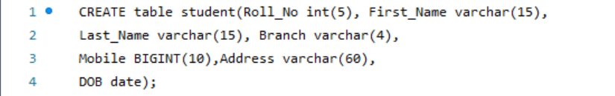

1. **DESCRIBE**

* To find information about columns like column name, their data types and other attributes of a table we can use DESCRIBE command.
* It is used to Describe the Structure/Schema of the Table.

**Syntax:**

DESCRIBE tablename;

**Implementation:**

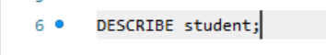

**Output:**

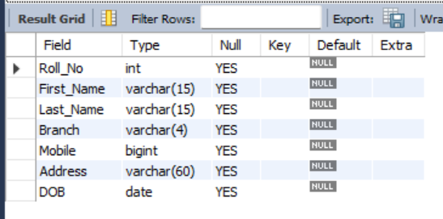

1. **ALTER**

* ALTER TABLE command is used to modify the structure of the table. It performs the following operations:
* Adding new Column in existing Table
* Dropping existing Column from Table
* Modifying Column definition in Table
* Renaming a Column in Table
* Adding constraint using alter command

**Syntax:**

* ALTER Table TableName ADD ( ColumnName1 datatype(size) constraint);
* ALTER Table TableName DROP ColumnName;
* ALTER Table TableName MODIFY ColumnName datatype(size);
* ALTER Table TableName RENAME COLUMN ColumnName1 TO ColumnName2;
* ALTER Table TableName ADD CONSTRAINT ConstraintName Constraint();
* ALTER Table TableName DROP CONSTRAINT ConstraintName;

**Implementation:**









**Output:**

ADD (Father_Name Added)

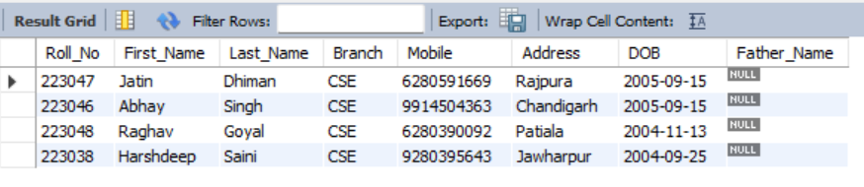

DROP (Father_Name Dropped)

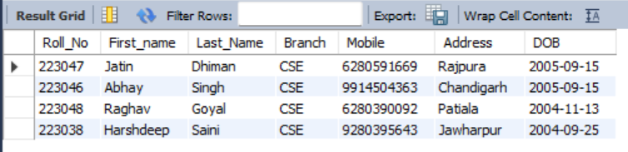

MODIFY (First_Name Attribute Datatype Modified)

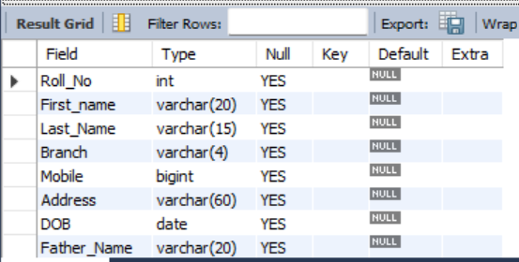

RENAME (Branch Renamed To Department)

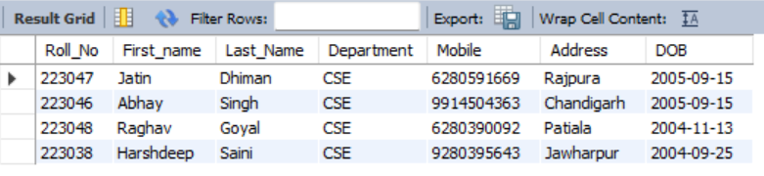

1. **RENAME**

* It is used to Rename the table name.

**Syntax:**

RENAME TABLE tableName1 to tableName2;

**Implementation:**



**Output:**

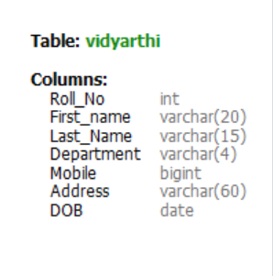

1. **TRUNCATE**

* Delete command deletes one row at a time, therefore truncate is used to delete all the rows from the table at the same time.
* It doesn’t delete the structure/schema of the table.
* Truncate is Faster than Delete.

**Syntax:**

* TRUNCATE TABLE tablename;

**Implementation:**



**Output:**

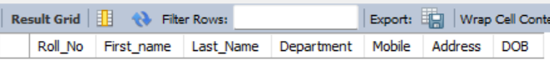

**DML Commands:**

1. **INSERT**

* To add new rows in an existing table the insert command is used.

**Syntax:**

* INSERT INTO tablename(col1,col2,col3...) VALUES(value1,value2,value3);
* INSERT INTO tablename VALUES(value1,value2,value3);

**Implementation:**



**Output:**

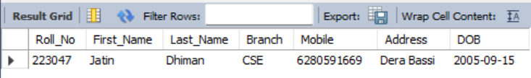

1. **UPDATE**

* Update command is used to change the record of the table. You can change all the rows or particular row from the table.
* The Update command specifies the row with where clause and new data is written into respective record using set keyword.

**Syntax:**

* UPDATE table_name set column1= newvalue ;
* Update table_name set column1= newvalue where (condition);

**Implementation:**

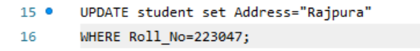

**Output:**

(Roll_No 223047 Address Updated)

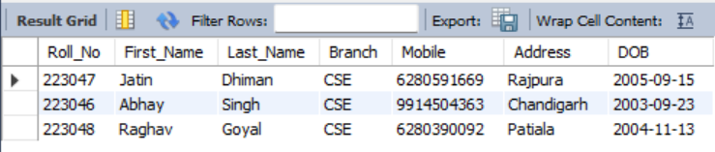

1. **DELETE**

* Delete Command is used to delete all rows or particular row from the table using where clause.
* The delete statement removes rows from table but it doesn’t release storage space. It doesn’t delete the structure/schema of the table.

**Syntax:**

* Delete from table_name ;
* Delete from table_name where (condition) ;

**Implementation:**

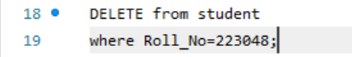

**Output:**

(Roll_No 223048 Deleted)

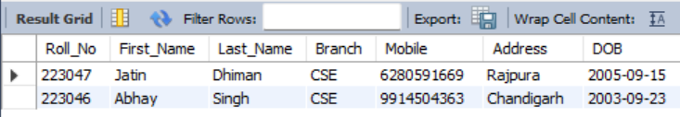

1. **SELECT**

* The select command of SQL lets you make queries on the database.
* It can be used to retrieve a subset of rows or columns from one or more tables.

**Syntax:**

The SELECT statement can be used in Many ways:

* SELECT column_name FROM table_name;
* SELECT * FROM table_name;
* SELECT DISTINCT column name(s) FROM table_name;
* SELECT column name FROM table_name WHERE Condition;
* SELECT column name FROM table_name WHERE Condition ORDER BY column name ASC/DESC;

**Implementation:**

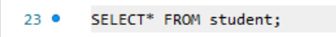







**Output:**

(All Columns Selected)

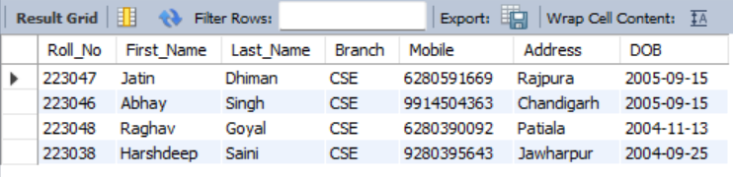

(Roll_No and DOB Selected)

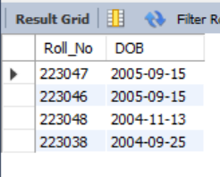

(Distinct DOB Selected)

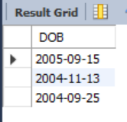

(Sorted in ascending order of Roll_No)

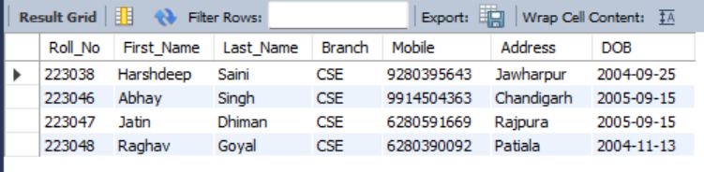

1. **Use of CREATE AS, USER_CONSTRAINTS,TAB, SPOOL ON**
2. **CREATE AS**

**Practical:- 2**

**Data Constraints and its types:**

SQL is Structured Query Language, which is a computer language for storing,

manipulating and retrieving data stored in a relational database.

SQL is Structured Query Language, which is a computer language for storing,

manipulating and retrieving data stored in a relational database.

SQL is Structured Query Language, which is a computer language for storing,

manipulating and retrieving data stored in a relational database.

SQL is Structured Query Language, which is a computer language for storing,

manipulating and retrieving data stored in a relational database.

SQL is Structured Query Language, which is a computer language for storing,

manipulating and retrieving data stored in a relational database.

SQL is Structured Query Language, which is a computer language for storing,

manipulating and retrieving data stored in a relational database.

SQL is Structured Query Language, which is a computer language for storing,

manipulating and retrieving data stored in a relational database.

SQL is Structured Query Language, which is a computer language for storing,

manipulating and retrieving data stored in a relational database.

SQL is Structured Query Language, which is a computer language for storing,

manipulating and retrieving data stored in a relational database.

SQL is Structured Query Language, which is a computer language for storing,

manipulating and retrieving data stored in a relational database.

SQL constraints are used to specify rules for the data in a table.

Constraints are used to limit the type of data that can go into a table. This ensures the accuracy and reliability of the data in the table. If there is any violation between the constraint and the data action, the action is aborted.

Constraints can be column level or table level. Column level constraints apply to a column, and table level constraints apply to the whole table.

The following constraints are commonly used in SQL:

* Primary key
* Foreign key
* Unique
* Not Null
* Check
* Default

1. **Naming of a Constraint**

**Types of Constraints: Column level, Table level**

1. **PRIMARY KEY**

A primary key constraint depicts a key comprising one or more columns that will help uniquely identify every tuple/record in a table.

**Properties :**

1. No duplicate values are allowed, i.e. Column assigned as primary key should have UNIQUE values only.
2. NO NULL values are present in column with Primary key.
3. Only one primary key per table exist although Primary key may have multiple columns.
4. No new row can be inserted with the already existing primary key.
5. Classified as :
   * + Simple primary key that has a Single column

PRIMARY KEY (Roll_No)

* + - Composite primary key has Multiple column.

PRIMARY KEY (Name, Address)

1. Defined in Create table / Alter table statement.

**Syntax:**

Column Level:

Column name datatype [ CONSTRAINT constraint_name] PRIMARY KEY

Table Level:

[CONSTRAINT constraint_name] PRIMARY KEY (column,. . .),

Using Alter:

ALTER TABLE tablename ADD CONSTRAINT constraint_name PRIMARY KEY(Attribute_name);

**Implementation:**

(Column Level Doesn’t work in MySQL)

(Table Level)

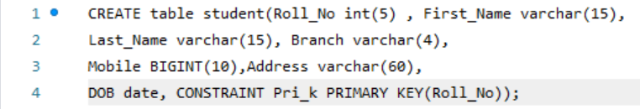

(Using Alter)



**Output:**

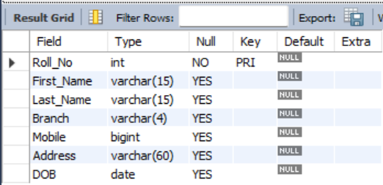

1. **FOREIGN KEY**

[Foreign Key](https://practice.geeksforgeeks.org/problems/what-is-a-foreign-key) is a column that refers to the primary key/unique key of other table. Foreign key ensures referential integrity.

**Properties :**

1. Parent that is being referenced has to be unique/Primary Key.
2. Child may have duplicates and nulls.
3. Parent record can be deleted if no child exists.
4. Master table cannot be updated if child exists.
5. Must reference PRIMARY KEY in primary table.
6. Foreign key column and constraint column should have matching data types.
7. Records cannot be inserted in child table if corresponding record in master table do not exist.
8. Records of master table cannot be deleted if corresponding records in child table exits.

**Syntax:**

Column Level:

CONSTRAINT constraint_name REFERENCES master_table(Attribute_name),

Table Level:

CONSTRAINT constraint_name FOREIGN KEY(Attribute_name) REFERENCES master_table(Attribute_name),

Using Alter:

ALTER TABLE tablename ADD FOREIGN KEY (Attribute_name) REFERENCES master_table(Attribute_name);

**Implementation:**

(Column Level Doesn’t work in MySQL)

(Table Level)



(Using Alter)



**Output:**

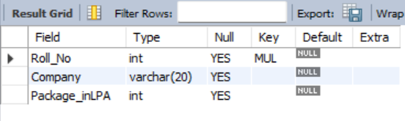

1. **UNIQUE**

The UNIQUE constraint requires that every value in a column or set of columns be unique.

**Properties :**

1. If a Column has a Unique Constraint, it means that Particular column cannot have duplicate values in a Table.
2. UNIQUE constraint enforces a column or set of columns to have unique values.

**Syntax:**

Column Level:

CREATE TABLE tablename (column_name1 datatype (size) constraint_name UNIQUE, column_name2..);

Table Level:

CREATE TABLE tablename (column_name1 datatype (size), column_name2.., CONSTRAINT constraint_name UNIQUE(column_name1) );

Alter Table:

ALTER TABLE tablename ADD CONSTRAINT constraint_name UNIQUE(Attribute_name);

**Implementation:**

(Column Level)

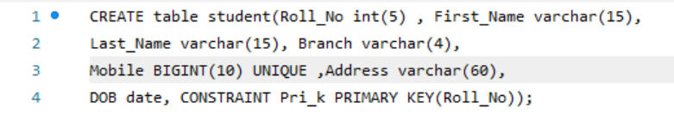

(Table Level)

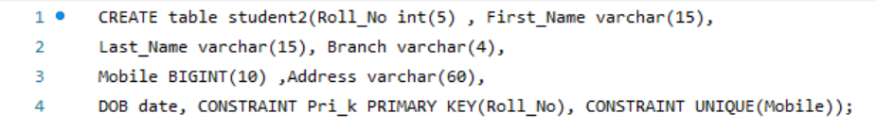

(Using Alter)



**Output:**

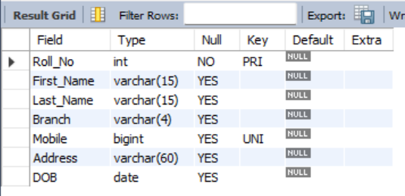

1. **NOT NULL**

The [SQL](https://www.geeksforgeeks.org/sql-tutorial/)NOT NULL forces particular values or records should not to hold a null value. It is somewhat similar to the primary key condition as the primary key can’t have null values in the table although both are completely different things

**Properties :**

1. NOT NULL Constraint makes sure that a column does not hold null value. When we don’t provide value for a particular column while inserting a record into a table, it takes null value by default.
2. By specifying null constraint, we can be sure that a particular column cannot have null values.

**Syntax:**

COLUMN_NAME DATA_TYPE(SIZE) NOT NULL

**Implementation:**

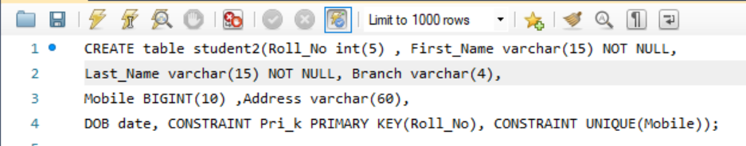

**Output:**

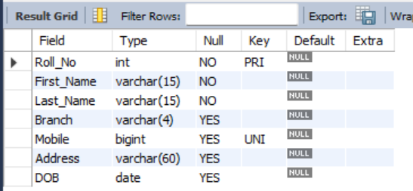

1. **DEFAULT**

The DEFAULT **Constraint** is used to fill a column with a default and fixed value. The value will be added to all new records when no other value is provided.

**Properties :**

1. The Default constraint provides a default value to a column when there is no value provided while inserting a record into a table.

**Syntax:**

CREATE TABLE tablename (Columnname **DEFAULT** ‘defaultvalue’ );

Using Alter:

* ALTER TABLE tablename MODIFY Attribute_name datatype(size) DEFAULT ‘default_value’;
* ALTER TABLE tablename ALTER Attribute_name SET DEFAULT ‘default_value’;

**Implementation:**



**Output:**

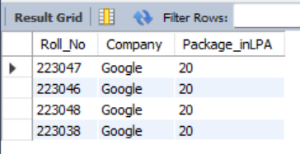

1. **CHECK**

This Constraint is used for Specifying range of Values for a particular column of a table.

**Properties :**

1. Ensures that the values in a column satisfies a specific condition.
2. If the value being added to an attribute of a tuple violates the check constraint, the check constraint evaluates to false and the corresponding update is aborted.

**Syntax:**

CREATE TABLE tablename (Columnname **CHECK(condition)**);

Using Alter:

* ALTER TABLE tablename MODIFY Attribute_name CHECK(condition);
* ALTER TABLE tablename ADD CONSTRAINT constraint_name CHECK(condition);

**Implementation:**

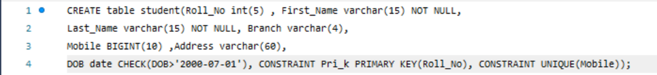



**Output:**



**Behaviours of foreign key table:**

1. **On delete/Update Restrict**

It prevents deleting/updating from parent table when child table is present. It is an Default Action.

1. **On Update(Delete) Cascade**

The default behavior of foreign key can be changed using ON DELETE CASCADE/ ON UPDATE CASCADE. When this option is specified in foreign key definition, if a record is deleted/updated in master table, all corresponding record in detail table will be deleted/updated.

**Syntax:**

CONSTRAINT constraint_name FOREIGN KEY(Attribute_name) REFERENCES master_table(Attribute_name) ON DELETE CASCADE ON UPDATE CASCADE,

**Implementation:**



**Output:**



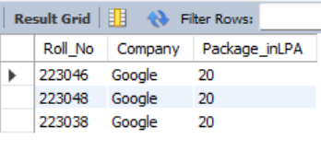(Data deleted from child table as well)

1. **On Update(Delete) SET NULL**

A Foreign key with SET NULL ON DELETE/UPDATE means if record in parent table is deleted/updated, corresponding records in child table will have foreign key fields set to null. Records in child table will not be deleted/updated.

**Syntax:**

CONSTRAINT constraint_name FOREIGN KEY(Attribute_name) REFERENCES master_table(Attribute_name) ON DELETE SET NULL ON UPDATE SET NULL,

**Implementation:**



**Output:**



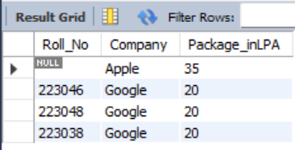(Data Set to null in child table)

**Practical:- 3**

1. **TCL (Transaction Control Language)**

* In SQL, TCL stands for Transaction control language.
* A single unit of work in a database is formed after the consecutive execution of commands is known as a transaction.
* There are certain commands present in SQL known as TCL commands that help the user manage the transactions that take place in a database.
* COMMIT. ROLLBACK, ROLLBACK TO and SAVEPOINT are the most commonly used TCL commands in SQL.

1. **COMMIT**

COMMIT command in SQL is used to save all the transaction-related changes permanently to the disk.

**Properties :**

1. Whenever DDL commands such as INSERT, UPDATE and DELETE are used, the changes made by these commands are permanent only after closing the current session.
2. So before closing the session, one can easily roll back the changes made by the DDL commands. Hence, if we want the changes to be saved permanently to the disk without closing the session, we will use the commit command

**Syntax:**

COMMIT;

**Note:-**

MySQL, by default, commits every query the user executes. But if the user wishes to commit only the specific queries instead of committing every query, then turning off the autocommit is useful.

**Syntax:**

SET AUTOCOMMIT=0;

**Implementation:**

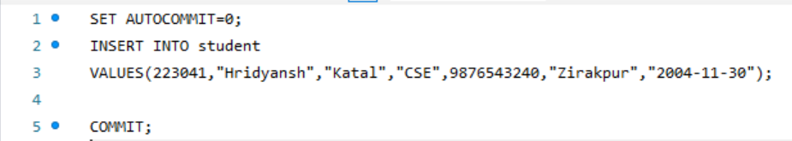

1. **SAVEPOINT**

Using the SAVEPOINT command in SQL, we can save these different parts of the same transaction using different names.

**Properties :**

* 1. To save all the insert related queries in one savepoint, we have to execute the SAVEPOINT query followed by the savepoint name after finishing the insert command execution.

**Syntax:**

SAVEPOINT savepoint_name;

**Implementation:**

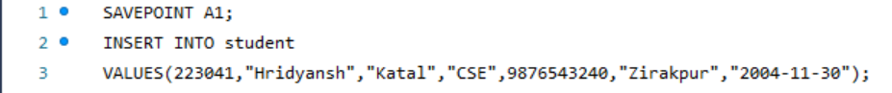

1. **ROLLBACK TO**

According to the user's changing requirements, he/she can roll back the transaction to different savepoints.

**Properties :**

1. ROLLBACK in SQL is a transactional control language that is used to undo the transactions that have not been saved in the database.
2. The command is only been used to undo changes since the last COMMIT.

**Syntax:**

ROLLBACK TO savepoint_name;

**Implementation:**

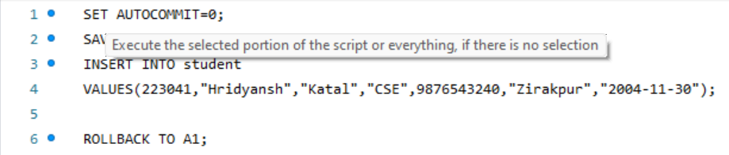

1. **ROLLBACK T**

It rolls back all the queries till the last commit.

**Syntax:**

ROLLBACK;

**Implementation:**

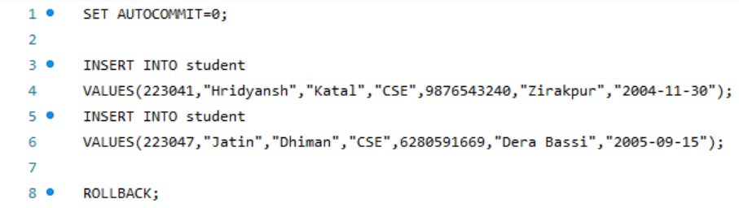

**Output:**

(NO Insertion of data because it got Rolled back)

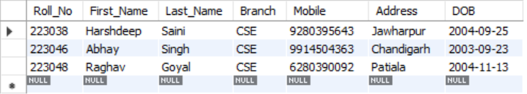

1. **DCL (Data Control Language)**

Data control language (DCL) is used to access the stored data. It is mainly used for revoke and to grant the user the required access to a database.

It is a part of the structured query language (SQL).It helps in controlling access to information stored in a database. It complements the data manipulation language (DML) and the data definition language (DDL).It is the simplest among three commands.

It provides the administrators, to remove and set database permissions to desired users as needed.

These commands are employed to grant, remove and deny permissions to users for retrieving and manipulating a database

1. **GRANT Command**

It is employed to grant a privilege to a user. GRANT command allows specified users to perform specified tasks

**Syntax:**

GRANT privilege_name on objectname to user;

* privilege names are SELECT,UPDATE,DELETE,INSERT,ALTER,ALL
* objectname is table name
* user is the name of the user to whom we grant privilege

**Implementation:**

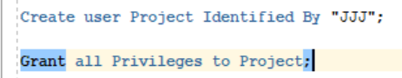

**Ouput:**

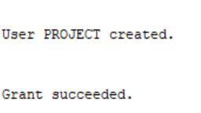

1. **REVOKE Command**

It is employed to remove a privilege from a user. REVOKE helps the owner to cancel previously granted permissions.

**Syntax:**

REVOKE privilege_name on objectname from user;

* privilege names are SELECT,UPDATE,DELETE,INSERT,ALTER,ALL
* objectname is table name
* user is the name of the user whose privileges are removing

**Implementation:**



**Output:**

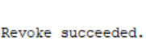

**Practical:- 4**

**SQL Operators and Functions:**

SQL is Structured Query Language, which is a computer language for storing,

manipulating and retrieving data stored in a relational database.

SQL is Structured Query Language, which is a computer language for storing,

manipulating and retrieving data stored in a relational database.

SQL is Structured Query Language, which is a computer language for storing,

manipulating and retrieving data stored in a relational database.

SQL is Structured Query Language, which is a computer language for storing,

manipulating and retrieving data stored in a relational database.

SQL is Structured Query Language, which is a computer language for storing,

manipulating and retrieving data stored in a relational database.

SQL is Structured Query Language, which is a computer language for storing,

manipulating and retrieving data stored in a relational database.

SQL is Structured Query Language, which is a computer language for storing,

manipulating and retrieving data stored in a relational database.

SQL is Structured Query Language, which is a computer language for storing,

manipulating and retrieving data stored in a relational database.

SQL is Structured Query Language, which is a computer language for storing,

manipulating and retrieving data stored in a relational database.

SQL is Structured Query Language, which is a computer language for storing,

manipulating and retrieving data stored in a relational database.

1. **OPERATORS**
2. **ARITHMETIC OPERATORS**

In Structured Query Language, the arithmetic operators are used to perform mathematical operations on the numerical values stored in the database tables.These types of operators are used between two numerical operands for performing addition, subtraction, multiplication, and division operations.

The arithmetic operators in SQL are categorized into the following five types:

* SQL Addition Operator (+)
* SQL Subtraction Operator (-)
* SQL Multiplication Operator (*)
* SQL Division Operator (/)
* SQL Modulus Operator (%)

**ADDITION OPERATOR(+)**

**Syntax:**

SELECT Column_Name_1 Addition_Operator Column_Name2 FROM Table_Name;

SELECT Column_Name_1 Addition_Operator Column_Name2 FROM Table_Name WHERE condition;

**Implementation:**



**Output:**

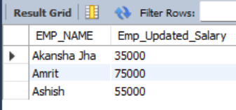

**SUBTRACTION OPERATOR(-)**

**Syntax:**

SELECT Column_Name_1 Subtraction_operator Column_Name2 FROM Table_Name;

SELECT Column_Name_1 Subtraction_operator Column_Name2 FROM Table_Name WHERE condition;

**Implementation:**



**Output:**

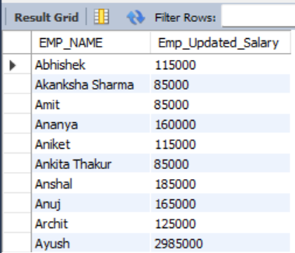

**MULTIPLICATION OPERATOR(*)**

**Syntax:**

SELECT Column_Name_1 Multiplication_Operator Column_Name2 FROM Table_Name;

SELECT Column_Name_1  Multiplication_Operator Column_Name2 FROM Table_Name WHERE condition;

**DIVISION OPERATOR(/)**

**Syntax:**

SELECT Column_Name_1 Addition_Operator Column_Name2 FROM Table_Name;

SELECT Column_Name_1 Addition_Operator Column_Name2 FROM Table_Name WHERE condition;

**MODULUS OPERATOR(%)**

**Syntax:**

SELECT Column_Name_1 Addition_Operator Column_Name2 FROM Table_Name;

SELECT Column_Name_1 Addition_Operator Column_Name2 FROM Table_Name WHERE condition;

1. **LOGICAL OPERATORS**

The Logical Operator is nothing but which returns the result in one form, i.e., either it will display the query is true, or the query is false. The results displayed to combine or merge more than one true or false data

The Logical Operators in SQL are as follows:

* AND OPERATOR
* OR OPERATOR
* NOT OPERATOR
* BETWEEN OPERATOR
* IN OPERATOR
* LIKE OPERATOR

**OR and IN OPERATOR**

**Implementation:**

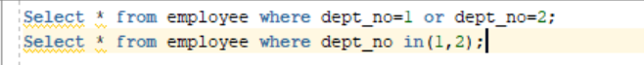

**Output:**

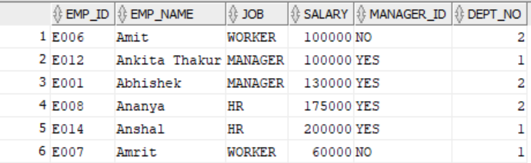

**AND and BETWEEN OPERATOR**

**Implementation:**



**Output:**

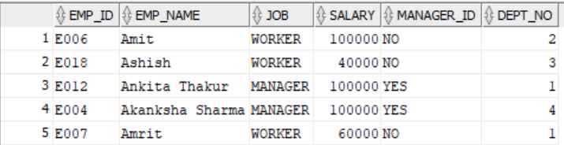

**NOT OPERATOR**

**Implementation:**

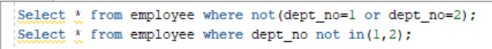

**Output:**

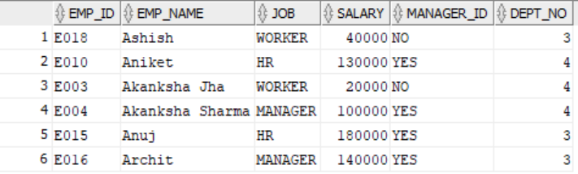

**LIKE OPERATOR**

**Implementation:**



**Output:**

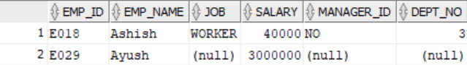

1. **RELATIONAL OPERATORS**

The SQL Operators which compare the values of two columns in the database tables are called as Relational operators.

The Relational Operators in SQL are as follows:

* Equal Operator (=)
* Not Equal Operator (!=)
* Greater Than Equals to Operator (>=)
* Less Than Operator (<)
* Greater Than Operator (>)
* Less Than Equals to Operator (<=)

1. **FUNCTIONS**
2. **STRING FUNCTIONS**

* INITCAP
* INSTR
* LENGTH
* LOWER
* LTRIM
* RTRIM
* SUBSTR
* UPPER
* **INITCAP**

Capitalizes the first letter of a string of characters.

**Implementation:**



**Output:**

Didn’t work in MySQL

* **INSTR**

Searches a character string for a character string subset and returns the start position and/or occurrence of the substring.

**Implementation:**



**Output:**

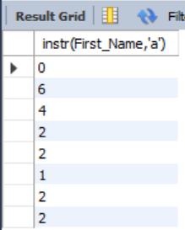

* **LTRIM AND RTRIM**

Trims either from left or right.

**Implementation:**



**Output:**

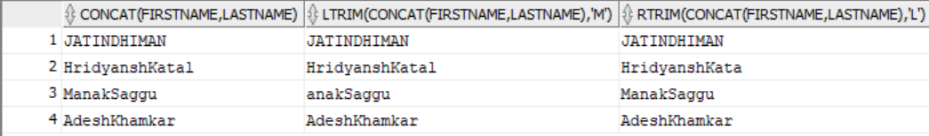

* **LENGTH**

Returns a numeric value Equivalent to number of characters in a string of characters

**Implementation:**



**Output:**

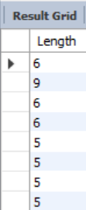

* **LOWER**

Returns a Character value that is all lower case.

**Implementation:**



**Output:**

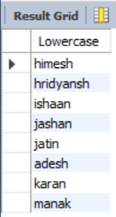

* **UPPER**

Returns a Character value that is all upper case.

**Implementation:**



**Output:**

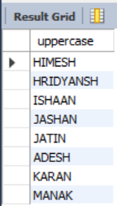

* **SUBSTR**

Returns a String of specified length from a larger character string beginning at a specified character position.

**Implementation:**



**Output:**

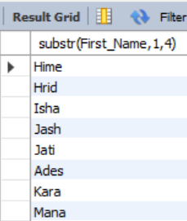

1. **NUMBER FUNCTIONS**

* ABS - SINH
* CEIL - TAN
* EXP - TANH
* FLOOR - ACOS
* SQRT - ASIN
* MOD - ATAN
* NVL -ATAN2
* POWER - COS
* ROUND - COSH
* TRUNC - LN
* LOG -SIGN
* SIN

**Some of The Implementations:**

**SIN and COS**

**Implementation:**

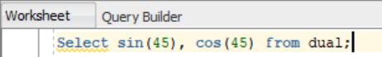

**Output:**

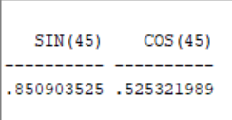

**ASIN and ACOS**

**Implementation:**



**Output:**

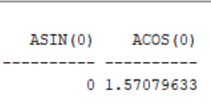

1. **DATE FUNCTIONS**

* DATE_ADD
* SYSDATE
* DATE_FORMAT
* TO_DATE
* **ADD_MONTHS**

Adds the specified number of months to the specified date and returns that date.

**Syntax:**

ADD_MONTHS(start_date, number_of_months)

**Implementation:**



**Output:**

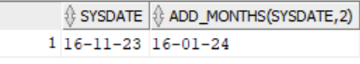

* **TO_CHAR**

Converts a date value to a character string

**Syntax:**

TO_CHAR(date_value, format_string)

**Implementation:**



**Output:**

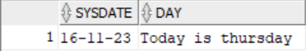

* **TO_DATE**

Converts a character string or number to a date value

**Syntax:**

TO_DATE(char_value, format_string)

**Implementation:**



**Output:**

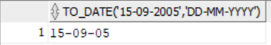

* **SYSDATE**

The SYSDATE() function returns the current date and time.

**Syntax:**

SYSDATE();

**Implementation:**

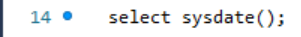

**Output:**

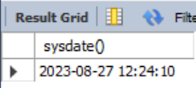

1. **AGGREGATE FUNCTIONS**

* COUNT
* SUM
* AVG
* MAX
* MIN
* **COUNT**

COUNT function is used to Count the number of rows in a database table. It can work on both numeric and non-numeric data types.

**Syntax:**

COUNT(*)

or

COUNT( [ALL|DISTINCT] expression )

**Implementation:**



COUNT WITH WHERE



COUNT WITH DISTINCT



COUNT WITH GROUP BY



COUNT WITH GROUP BY HAVING



**Output:**

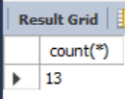

COUNT WITH WHERE

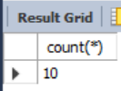

COUNT WITH DISTINCT

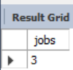

COUNT WITH GROUP BY

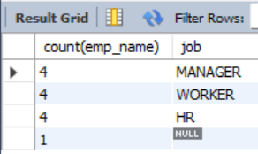

COUNT WITH GROUP BY HAVING

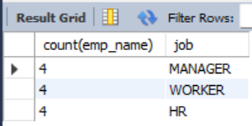

* **SUM**

Sum function is used to calculate the sum of all selected columns. It works on numeric fields only.

**Syntax:**

SUM()

or

SUM( [ALL|DISTINCT] expression )

**Implementation:**



SUM WITH WHERE



SUM WITH GROUP BY



SUM WITH GROUP BY HAVING



**Output:**

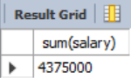

SUM WITH GROUP BY

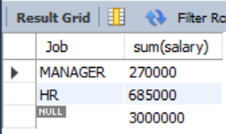

SUM WITH GROUP BY HAVING

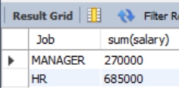

* **AVG**

The AVG function is used to calculate the average value of the numeric type. AVG function returns the average of all non-Null values.

**Syntax:**

AVG()

or

AVG( [ALL|DISTINCT] expression )

**Implementation:**



**Output:**

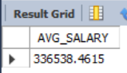

* **MAX**

MAX function is used to find the maximum value of a certain column. This function determines the largest value of all selected values of a column.

**Syntax:**

MAX()

or

MAX( [ALL|DISTINCT] expression )

**Implementation:**



**Output:**

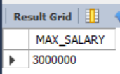

* **MIN**

MIN function is used to find the minimum value of a certain column. This function determines the smallest value of all selected values of a column.

**Syntax:**

MIN()

or

MIN( [ALL|DISTINCT] expression )

**Implementation:**



**Output:**

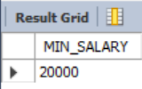

**Practical:- 5**

**ORDER BY, GROUP BY AND HAVING STATEMENTS**

**INTRODUCTION**

SQL is Structured Query Language, which is a computer language for storing,

manipulating and retrieving data stored in a relational database.

SQL is Structured Query Language, which is a computer language for storing,

manipulating and retrieving data stored in a relational database.

SQL is Structured Query Language, which is a computer language for storing,

manipulating and retrieving data stored in a relational database.

SQL is Structured Query Language, which is a computer language for storing,

manipulating and retrieving data stored in a relational database.

SQL is Structured Query Language, which is a computer language for storing,

manipulating and retrieving data stored in a relational database.

SQL is Structured Query Language, which is a computer language for storing,

manipulating and retrieving data stored in a relational database.

SQL is Structured Query Language, which is a computer language for storing,

manipulating and retrieving data stored in a relational database.

SQL is Structured Query Language, which is a computer language for storing,

manipulating and retrieving data stored in a relational database.

SQL is Structured Query Language, which is a computer language for storing,

manipulating and retrieving data stored in a relational database.

SQL is Structured Query Language, which is a computer language for storing,

manipulating and retrieving data stored in a relational database.

* A clause in SQL is a built-in function that helps to fetch the required columns or records faster from a database table. Clauses in SQL help us filter and provide the user with the required data according to their query.
* SQL clause helps us to retrieve a set or bundles of records from the table.
* SQL clause helps us to specify a condition on the columns or the records of a table.

Here are some commonly used SQL clauses:

* **WHERE CLAUSE:**
* A WHERE clause in SQL is a powerful tool used to filter and retrieve specific data from a table based on specified conditions. It is primarily used with the SELECT query, which is a data manipulation language command for retrieving data.
* It is used to filter the rows based on specified conditions. Only the rows that meet the conditions will be included in the result set.
* The WHERE clause is not limited to the SELECT query; it can also be used with other SQL statements like UPDATE and DELETE.

**Syntax of where clause with a select query to retrieve all the column values for every record from a table:**

SELECT * FROM TABLENAME WHERE CONDITION;

**If according to the requirement, we only want to retrieve selective columns, then we will use below syntax:**

SELECT column1, column2 FROM table_name WHERE condition;

**Implementation:**



**Output:**



* **GROUP BY CLAUSE:**
* The Group By clause is used to arrange similar kinds of records into the groups.
* It groups the rows based on one or more columns and is often used in combination with aggregate functions i.e., max(), min(), avg(), sum(), count() to perform calculations on groups of data.

**The syntax of Group By clause:**

SELECT * FROM TABLENAME GROUP BY COLUMNNAME;

**The syntax of Group By clause with Aggregate Functions:**

SELECT column1, aggregate_function(column2) FROM table_name GROUP BY column1;

**Implementation:**



**Output:**



* **HAVING CLAUSE:**
* It is used to filter the grouped rows based on specified conditions. It is similar to the WHERE clause but is applied to the grouped data.

**Syntax:**

TABLENAME GROUP BY COLUMNNAME HAVING CONDITION;

**Implementation:**



**Output:**



* **ORDER BY CLAUSE:**
* ORDER BY CLAUSE sorts the data in ascending or descending order as per our requirement.
* By default, sorting in the SQL will be done using the ORDER BY clause in ASCENDING order if we didn't mention the sorting order.

**Syntax of ORDER BY clause:**

SELECT COLUMN_NAME1, COLUMN_NAME2 FROM TABLE_NAME ORDER BY COLUMN_NAME DESC;

same for ASC OR no need to mention, it takes by default.

**Implementation:**



**Output:**

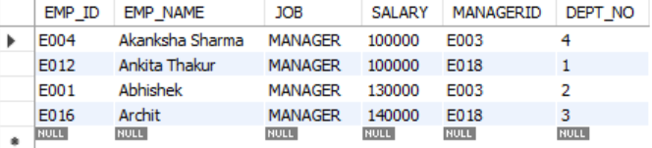

**Practical:- 6**

**NESTED QUERIES**

SQL is Structured Query Language, which is a computer language for storing,

manipulating and retrieving data stored in a relational database.

SQL is Structured Query Language, which is a computer language for storing,

manipulating and retrieving data stored in a relational database.

SQL is Structured Query Language, which is a computer language for storing,

manipulating and retrieving data stored in a relational database.

SQL is Structured Query Language, which is a computer language for storing,

manipulating and retrieving data stored in a relational database.

SQL is Structured Query Language, which is a computer language for storing,

manipulating and retrieving data stored in a relational database.

SQL is Structured Query Language, which is a computer language for storing,

manipulating and retrieving data stored in a relational database.

SQL is Structured Query Language, which is a computer language for storing,

manipulating and retrieving data stored in a relational database.

SQL is Structured Query Language, which is a computer language for storing,

manipulating and retrieving data stored in a relational database.

SQL is Structured Query Language, which is a computer language for storing,

manipulating and retrieving data stored in a relational database.

SQL is Structured Query Language, which is a computer language for storing,

manipulating and retrieving data stored in a relational database.

1. **SUBQUERIES (Single Row, Multiple Row)**

In Subquery inner Query is Executed First and Result of inner query is given to outer query.A Subquery is a query within another SQL query and embedded within theWHERE clause.

* A subquery can be placed in a number of SQL clauses like WHERE clause,FROM clause, HAVING clause.
* You can use Subquery with SELECT, UPDATE, INSERT, DELETEstatements along with the operators like =, <, >, >=, <=, IN, BETWEEN,etc.
* A subquery is a query within another query. The outer query is known as themain query, and the inner query is known as a subquery.
* Subqueries are on the right side of the comparison operator.
* A subquery is enclosed in parentheses.
* In the Subquery, ORDER BY command cannot be used. But GROUP BYcommand can be used to perform the same function as ORDER BYcommand.

**Note:**

Subqueries are useful when a query is based on unknown values.

**Sub Queries with SELECT Statement:**

**Syntax:**

SELECT column_name

FROM table_name

WHERE column_name expression operator

(SELECT column_name from table_name WHERE …);

**Types of Subqueries:**

**Single Row Sub Query:**

Sub query which returns single row output. They mark the usage of single row comparison operators, when used in WHERE conditions.

Operators

* =
* <>
* <
* >
* <=
* >=
* **= Operator**

**Implementation:**



**Output:**

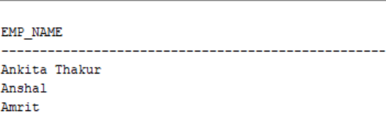

* **<> Operator**

**Implementation:**



**Output:**

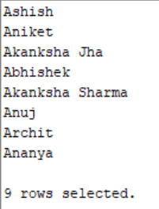

* **<= Operator**

**Implementation:**



**Output:**

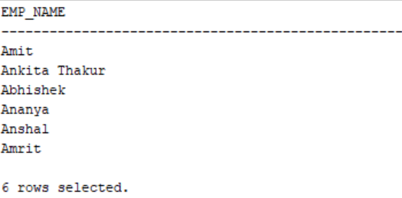

* **>= Operator**

**Implementation:**



**Output:**

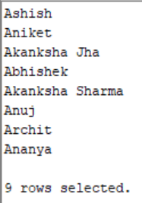

**Multiple row sub query:**

Sub query returning multiple row output. They makeuse of multiple row comparison operators like IN, ANY, ALL. There can be subqueries returning multiple columns also.

Operators

* IN (instead of equality)
* NOT IN
* <ANY, <SOME, <ALL
* >ANY, >SOME, >ALL
* <=ANY, <=SOME, <=ALL
* >=ANY, >=SOME, >=ALL
* **IN Operator**

**Implementation:**



**Output:**

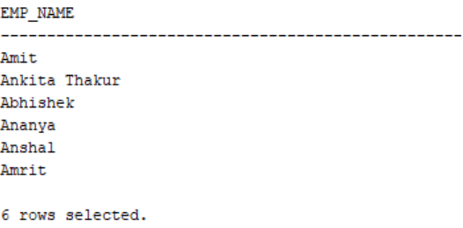

* **ANY Operator**

**Implementation:**



**Output:**

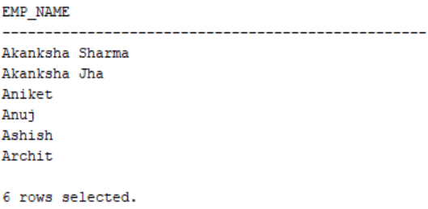

* **ALL Operator**

**Implementation:**



**Output:**

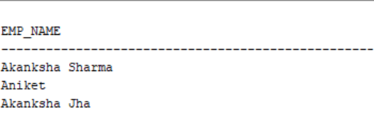

1. **CORRELATED QUERIES (Single Row, Multiple Row)**

In Correlated Query, Outer Query is Executed First and Result of outer query is given to inner query

**Implementation:**

Highest Paid Employee



**Output:**

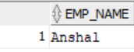

**Practical:- 7**

**SQL JOINS**

SQL is Structured Query Language, which is a computer language for storing,

manipulating and retrieving data stored in a relational database.

SQL is Structured Query Language, which is a computer language for storing,

manipulating and retrieving data stored in a relational database.

SQL is Structured Query Language, which is a computer language for storing,

manipulating and retrieving data stored in a relational database.

SQL is Structured Query Language, which is a computer language for storing,

manipulating and retrieving data stored in a relational database.

SQL is Structured Query Language, which is a computer language for storing,

manipulating and retrieving data stored in a relational database.

SQL is Structured Query Language, which is a computer language for storing,

manipulating and retrieving data stored in a relational database.

SQL is Structured Query Language, which is a computer language for storing,

manipulating and retrieving data stored in a relational database.

SQL is Structured Query Language, which is a computer language for storing,

manipulating and retrieving data stored in a relational database.

SQL is Structured Query Language, which is a computer language for storing,

manipulating and retrieving data stored in a relational database.

SQL is Structured Query Language, which is a computer language for storing,

manipulating and retrieving data stored in a relational database.

SQL JOINS are used to retrieve data from multiple tables. A SQL JOIN is performed whenever two or more tables are joined in a SQL command.

We can join the table using a **SELECT** statement and a **join condition.** It indicates how SQL Server can use data from one table to select rows from another table. In general, tables are related to each other using **foreign key** constraints.

If data is required from two tables then we need to join them.

There are 4 different types of SQL joins:

* + SQL CROSS JOIN
  + SQL INNER JOIN (or sometimes called simple join)
  + SQL NATURAL JOIN
  + SQL OUTER JOIN( left, right, full)

1. **CROSS JOIN**

CROSS JOIN in SQL Server combines all of the possibilities of two or more tables and returns a result that includes every row from all contributing tables. It's also known as **CARTESIAN JOIN** because it produces the**Cartesian product** of all linked tables. The Cartesian product represents all rows present in the first table multiplied by all rows present in the second table.

**Syntax:**

SELECT column_name_list

FROM table_name1 CROSS JOIN table_name2

**Implementation:**

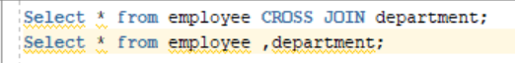

**Output:**

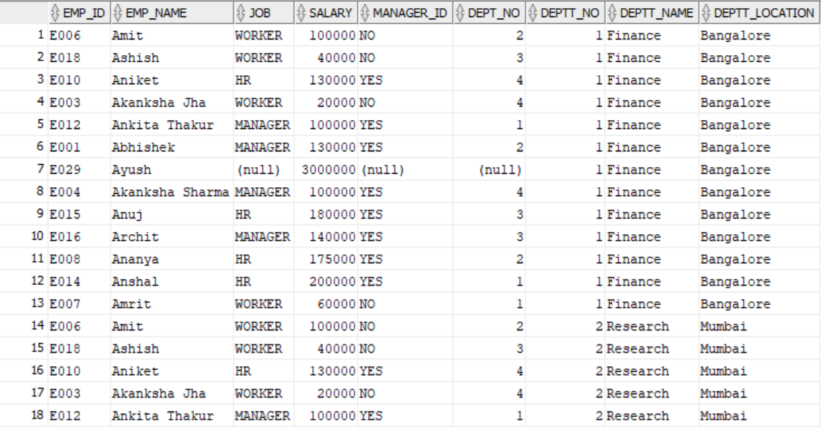 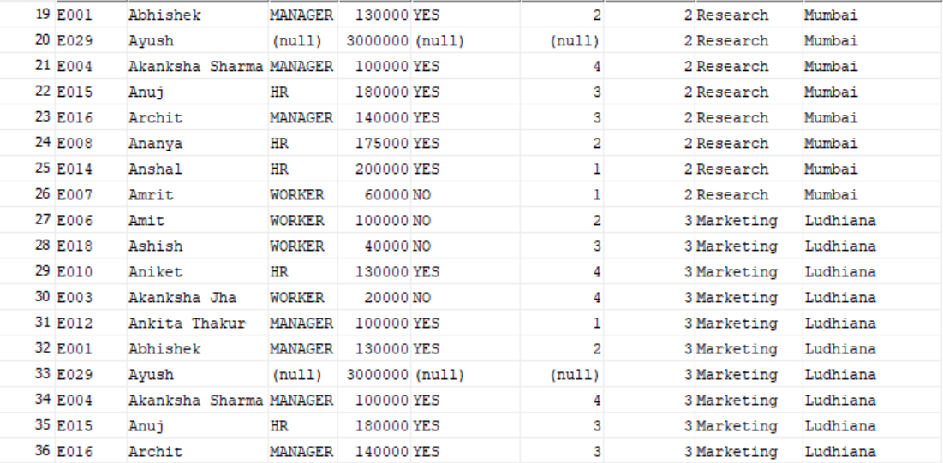 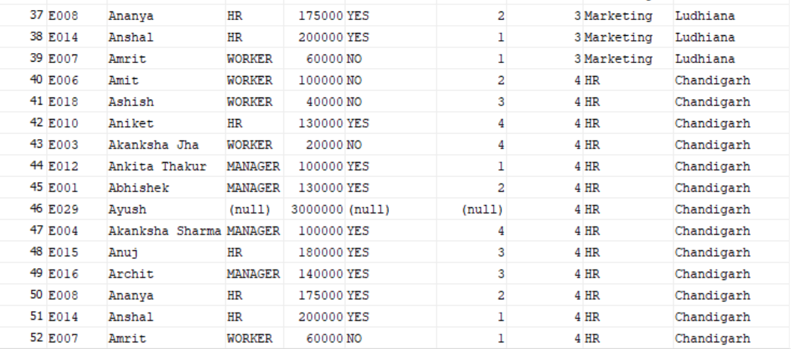

1. **INNER JOIN**

This JOIN returns all records from multiple tables that satisfy the specified join condition. If we omit the INNER keyword with the JOIN query, we will get the same output.

**Syntax:**

SELECT column_name_list

FROM table_name1 INNER JOIN table_name2

WHERE table_name1.column_name=table_name2.column_name;

**Note:**  ON keyword can also be used instead of WHERE to specify condition.

**Implementation:**



**Output:**

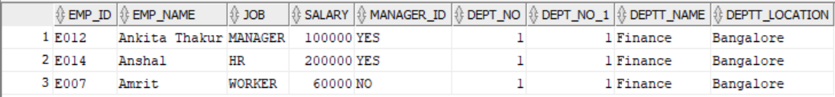

1. **NATURAL JOIN**

**A natural join is a type of join operation that creates an implicit join by combining tables based on columns with the same name and data type.**

There is no need to specify the column names to join. The resultant table always contains unique columns. It is possible to perform a natural join on more than two tables. Do not use the ON/WHERE clause.

**Syntax:**

SELECT * FROM table_name1 NATURAL JOIN table_name2;

**Implementation:**



**Output:**

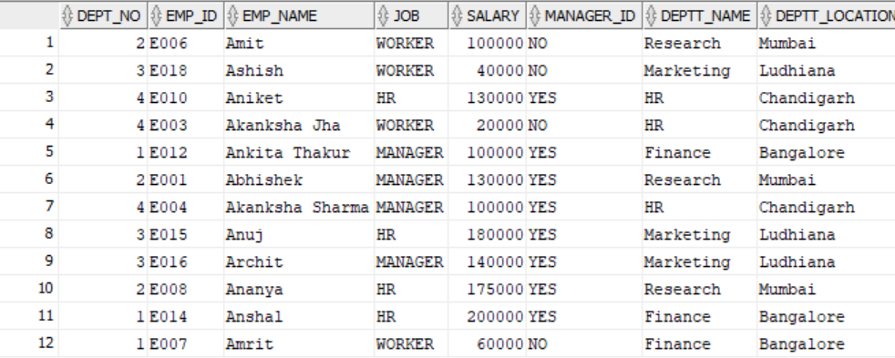

**Note:**  Natural Join always eliminates duplicate occurrence of common columns whereas equi join do not eliminates. Also Joining Criteria is Already Defined iin Natural Join. And If the tables do not have common columns then result of natural join is same as CROSS JOIN

1. **OUTER JOIN**

OUTER JOIN in SQL Server **returns all records from both tables** that satisfy the join condition. In other words, this join will not return only the matching record but also return all unmatched rows from one or both tables.

* **LEFT OUTER JOIN**

This type of join returns all rows from the LEFT-hand table specified in the ON/WHERE condition and returns only those rows from the other table where the joined fields are equal (join condition is met )

LEFT OUTER JOIN = INNER JOIN + ROWS LEFT IN THE LEFT TABLE

**Syntax:**

SELECT column_name_list

FROM table_name1 LEFT [OUTER] JOIN table_name2

WHERE table_name1.column_name=table_name2.column_name;

**OR**

SELECT column_name_list

FROM table_name1,table_name2

WHERE table_name1.column_name=table_name2.column_name(+);

**Implementation:**



**Output:**

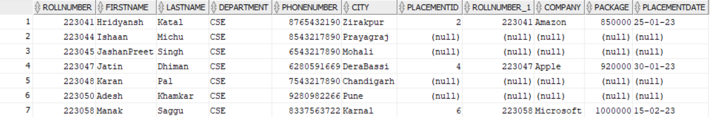

* **RIGHT OUTER JOIN**

The RIGHT OUTER JOIN **retrieves all the records from the right-hand table and matched rows from the left-hand table.** It will return **NULL** when no matching record is found in the left-hand table. Since OUTER is an optional keyword, it is also known as RIGHT JOIN.

RIGHT JOIN = INNER JOIN + ROWS LEFT IN RIGHT TABLE

**Syntax:**

SELECT column_name_list

FROM table_name1 RIGHT [OUTER] JOIN table_name2

WHERE table_name1.column_name=table_name2.column_name;

**OR**

SELECT column_name_list

FROM table_name1,table_name2

WHERE table_name1.column_name=table_name2.column_name(-);

**Implementation:**



**Output:**



* **FULL OUTER JOIN**

This type of join returns all rows from the LEFT-hand table and RIGHT-hand table with nulls in place where the join condition is not met.

FULL OUTER JOIN = INNER JOIN + ROWS LEFT IN THE LEFT TABLE + ROWS LEFT IN THE RIGHT TABLE

**Syntax:**

SELECT column_name_list

FROM table_name1 FULL [OUTER] JOIN table_name2

WHERE table_name1.column_name=table_name2.column_name;

**Implementation:**



**Output:**

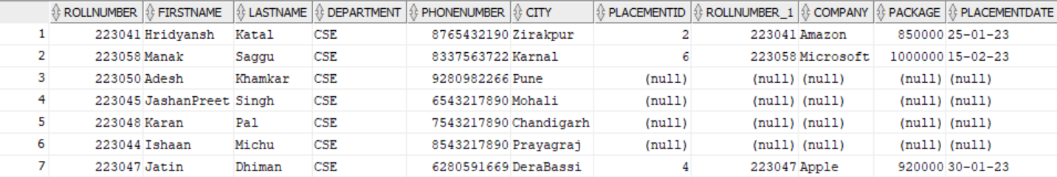

**# Set Operations**

* **Union**

**Implementation:**

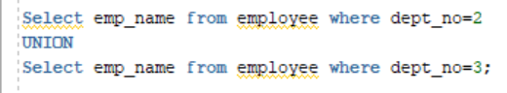

**Output:**

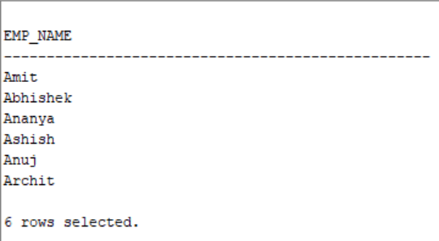

**Note:** Union compatible

They have same no. of columns and their domains should be same.

* **INTERSECTION**

**Implementation:**

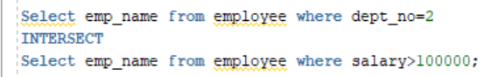

**Output:**

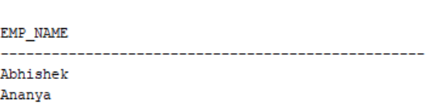

**Practical:- 8**

**VIEWS**

SQL is Structured Query Language, which is a computer language for storing,

manipulating and retrieving data stored in a relational database.

SQL is Structured Query Language, which is a computer language for storing,

manipulating and retrieving data stored in a relational database.

SQL is Structured Query Language, which is a computer language for storing,

manipulating and retrieving data stored in a relational database.

SQL is Structured Query Language, which is a computer language for storing,

manipulating and retrieving data stored in a relational database.

SQL is Structured Query Language, which is a computer language for storing,

manipulating and retrieving data stored in a relational database.

SQL is Structured Query Language, which is a computer language for storing,

manipulating and retrieving data stored in a relational database.

SQL is Structured Query Language, which is a computer language for storing,

manipulating and retrieving data stored in a relational database.

SQL is Structured Query Language, which is a computer language for storing,

manipulating and retrieving data stored in a relational database.

SQL is Structured Query Language, which is a computer language for storing,

manipulating and retrieving data stored in a relational database.

SQL is Structured Query Language, which is a computer language for storing,

manipulating and retrieving data stored in a relational database.

1. **INTRODUCTION**
   * + Views in SQL are considered as a virtual table. A view also contains rows and columns. To create the view, we can select the fields from one or more tables present in the database. A view can either have specific rows based on certain condition or all the rows of a table.
     + They are created using the select query, but the result is not stored in the physical memory. Every time we fire the query to the view, the view returns the updated and latest data from the original table. It means the views are generated every time the view is accessed.
     + We can create as many views we want.
2. **TYPES: MATERIALISED AND VIEW RESOLUTION**
3. **FEATURES/ADVANTAGES**
4. **CREATE, DROP VIEW( using single table, Multiple Tables)**
5. **CREATE VIEW**

A view can be created using the **CREATE VIEW** statement. We can create a view from a single table or multiple tables.

* + - **Single table**

**Syntax:**

CREATE VIEW view_name AS

SELECT column1, column2.....

FROM table_name

WHERE condition;

**Implementation:**





**Output:**

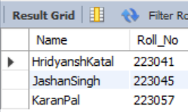

* + - **Multiple Tables**

**Implementation:**





**Output:**

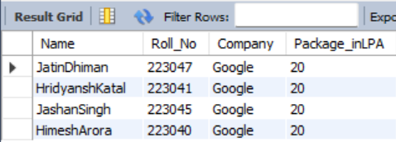

1. **DROP VIEW**

A view can be deleted using the Drop View statement.

**Syntax:**

DROP VIEW view_name;

**Implementation:**



**Output:**



1. **INSERT UPDATE DELETE IN VIEWS**

**Single table**



Output:

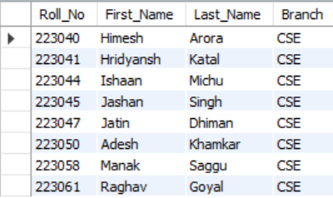

* **Updating the View:**



Output:

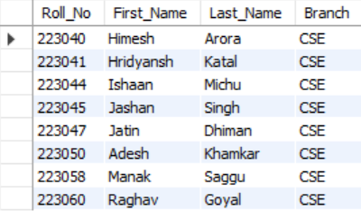 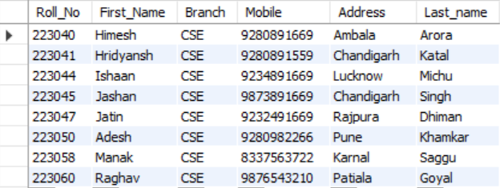

(Virtual Table) (Parent Table also Updated)

* **Deleting From The View:**



Output:

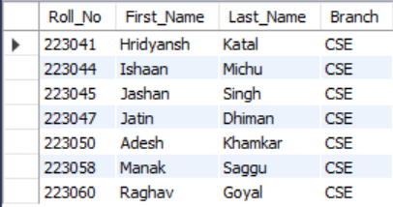 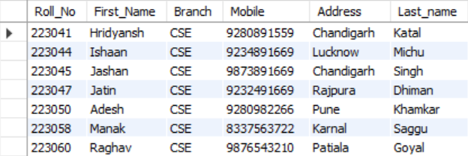

(Virtual Table) (Deleted from Parent Table as Well)

* **Inserting Into the View:**



Output:

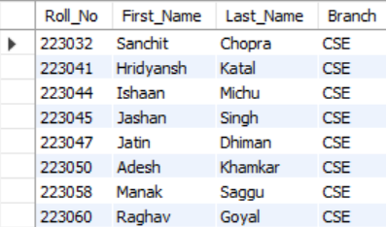 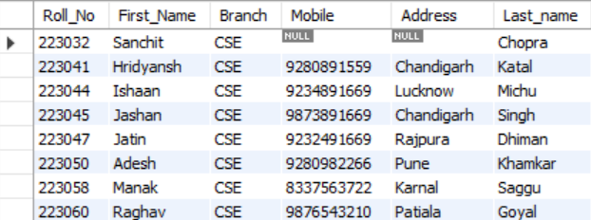

(Virtual Table) (Inserted into Parent Table as well)

**Multiple Tables**



Output:

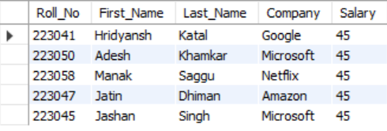

* **Updating the View:**



Output:

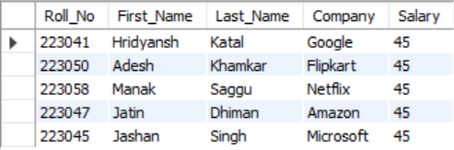 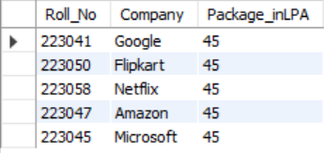

(Virtual Table) (Parent Table also Updated)

If a view is based on multiple tables, and if you update the view, it may not update the underlying base tables correctly. To correctly Update a view, that is based on multiple Table, INSTEAD OF triggers are used.

* **Deleting From The View:**



Output:



* **Inserting Into the View:**



Outpu:



**Practical:- 9**

**INDEXES**

SQL is Structured Query Language, which is a computer language for storing,

manipulating and retrieving data stored in a relational database.

SQL is Structured Query Language, which is a computer language for storing,

manipulating and retrieving data stored in a relational database.

SQL is Structured Query Language, which is a computer language for storing,

manipulating and retrieving data stored in a relational database.

SQL is Structured Query Language, which is a computer language for storing,

manipulating and retrieving data stored in a relational database.

SQL is Structured Query Language, which is a computer language for storing,

manipulating and retrieving data stored in a relational database.

SQL is Structured Query Language, which is a computer language for storing,

manipulating and retrieving data stored in a relational database.

SQL is Structured Query Language, which is a computer language for storing,

manipulating and retrieving data stored in a relational database.

SQL is Structured Query Language, which is a computer language for storing,

manipulating and retrieving data stored in a relational database.

SQL is Structured Query Language, which is a computer language for storing,

manipulating and retrieving data stored in a relational database.

SQL is Structured Query Language, which is a computer language for storing,

manipulating and retrieving data stored in a relational database.

1. **INTRODUCTION**
   * + The Index in SQL is a special table used to speed up the searching of the data in the database tables. It also retrieves a vast amount of data from the tables frequently. The INDEX requires its own space in the hard disk.
     + In SQL, an Index is created on the fields of the tables. We can easily build one or more indexes on a table. The creation and deletion of the Index do not affect the data of the database.
     + SQL Indexes can search the information of the large database quickly.
     + This concept is a quick process for those columns, including different values.
     + This data structure sorts the data values of columns (fields) either in ascending or descending order. And then, it assigns the entry for each value.
     + Each Index table contains only two columns. The first column is row_id, and the other is indexed-column.
     + When indexes are used with smaller tables, the performance of the index may not be recognized.
2. **TYPES: UNIQUE, DUPLICATE, SIMPLE, COMPOSITE**

* **UNIQUE INDEX**
* Index can be used to enforce uniqueness on column(s) in a table
* PRIMARY KEY and UNIQUE constraints are actually implemented by Oracle DBMS defining a UNIQUE index

**Syntax:**

CREATE UNIQUE INDEX index_name ON tablename(col1name,…..)

**Implementation:**



* **COMPOSITE INDEX**
* If defining an index on a composite field, the order of the columns is significant : list the most commonly queried column first so that the index can be used for this single column or for the combined columns

**Syntax:**

CREATE INDEX index_name ON tablename(col1name,…..)

**Implementation:**



1. **CREATE/ DROP INDEX (on single column and multiple columns)**

**Why we need to create Index ?**



**Output:**



The search scans 13 rows to find the employees having salary 40000.

Creating Indexes makes the searching faster by scanning less rows.

**CREATING INDEX:**

**Single Column**

**Syntax:**

Create index index_name on table_name(column_name);

**Implementation:**





**Output:**



The search scans lesser rows i.e one to find the employees having salary 40000.

**Multiple Columns**

**Syntax:**

Create index index_name on table_name(column_name1, column_name2…);

**Implementation:**





**Output:**



The search scans lesser rows i.e one to find the employees having salary 40000.

**DROPING INDEX:**

**Syntax:**

Drop index index_name on table_name;

**Implementation:**



**Practical:- 10**

**SEQUENCES**

SQL is Structured Query Language, which is a computer language for storing,

manipulating and retrieving data stored in a relational database.

SQL is Structured Query Language, which is a computer language for storing,

manipulating and retrieving data stored in a relational database.

SQL is Structured Query Language, which is a computer language for storing,

manipulating and retrieving data stored in a relational database.

SQL is Structured Query Language, which is a computer language for storing,

manipulating and retrieving data stored in a relational database.

SQL is Structured Query Language, which is a computer language for storing,

manipulating and retrieving data stored in a relational database.

SQL is Structured Query Language, which is a computer language for storing,

manipulating and retrieving data stored in a relational database.

SQL is Structured Query Language, which is a computer language for storing,

manipulating and retrieving data stored in a relational database.

SQL is Structured Query Language, which is a computer language for storing,

manipulating and retrieving data stored in a relational database.

SQL is Structured Query Language, which is a computer language for storing,

manipulating and retrieving data stored in a relational database.

SQL is Structured Query Language, which is a computer language for storing,

manipulating and retrieving data stored in a relational database.

1. **INTRODUCTION**
   * + Oracle provides the capability to generate sequences of unique numbers, and they are called **sequences.**
     + A sequence object can be defined as a user-defined object which is bound to the schema that generates a numeric values sequence according to the increment value that is defined at the time of the creation of the sequence.
     + Just like tables, views, indexes, and synonyms, a sequence is a type of database object.
     + Sequences are used to generate unique, sequential integer values that are used as primary key values in database tables.
     + The sequence of numbers can be generated in either ascending or descending order.
2. **CREATE, DROP SEQUENCE**

**CREATING SEQUENCE:**

**Syntax:**

The syntax of the CREATE SEQUENCE command is fairly complex because it has numerous optional clauses.

CREATE SEQUENCE <sequence name>

[INCREMENT BY <number>]

[START WITH <start value number>]

[MAXVALUE <MAXIMUM VALUE NUMBER>]

[NOMAXVALUE]

[MINVALUE <minimum value number>]

[CYCLE]

[NOCYCLE]

[CACHE <number of sequence value to cache>]

[NOCACHE]

[ORDER]

[NOORDER];

**If optional clauses are not used the By default values are:**

increment = 1

start with minvalue

max = 10^27

min = 10^-26

nocycle

cache =(CEIL(MAXVALUE – MINVALUE)) / ABS (INCREMENT)

seq.currval – display current value seq

seq.nextval – generate next value of seq

* **Basic Implementation:**

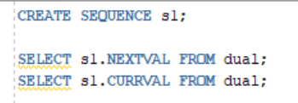

**Output:**

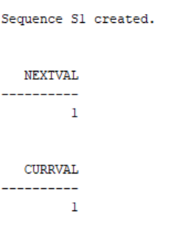

**DROPPING SEQUENCE:**

* DROP SEQUENCE command is used to drop sequences that need to be recreated or are no longer needed.
* The general format is shown here along with an example that drops the order_number_sequence;

**Syntax:**

DROP SEQUENCE <sequence name>

Eg. DROP SEQUENCE order_number_sequence;

**Implementation:**

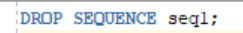

**Output:**

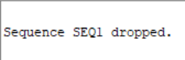

1. **USING SEQUENCE TO INSERT VALUES IN COLUMN OF A TABLE(ex employee id, student rollno etc)**

* **Main Implementation**





**Output:**

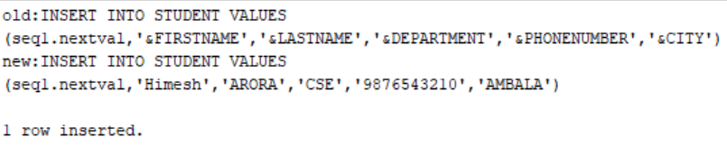

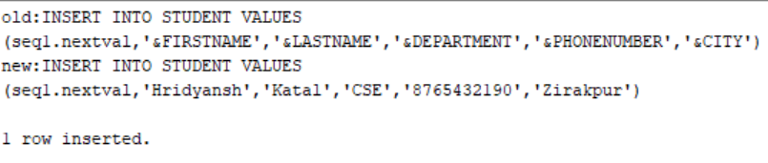

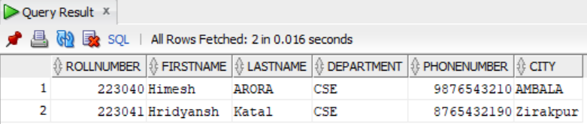

**Note:**

* **Values are getting inserted in the database with primary key has been taken care of by sequence**
* **We can also See how many records inserted using currval Datatype**

**Practical:- 11**

**INTRODUCTION TO PL/SQL**

SQL is Structured Query Language, which is a computer language for storing,

manipulating and retrieving data stored in a relational database.

SQL is Structured Query Language, which is a computer language for storing,

manipulating and retrieving data stored in a relational database.

SQL is Structured Query Language, which is a computer language for storing,

manipulating and retrieving data stored in a relational database.

SQL is Structured Query Language, which is a computer language for storing,

manipulating and retrieving data stored in a relational database.

SQL is Structured Query Language, which is a computer language for storing,

manipulating and retrieving data stored in a relational database.

SQL is Structured Query Language, which is a computer language for storing,

manipulating and retrieving data stored in a relational database.

SQL is Structured Query Language, which is a computer language for storing,

manipulating and retrieving data stored in a relational database.

SQL is Structured Query Language, which is a computer language for storing,

manipulating and retrieving data stored in a relational database.

SQL is Structured Query Language, which is a computer language for storing,

manipulating and retrieving data stored in a relational database.

SQL is Structured Query Language, which is a computer language for storing,

manipulating and retrieving data stored in a relational database.

1. **SYNTAX OF PL/SQL**

PL/SQL block has following structure

DECLARE

Declaration statements -- Optional

BEGIN

Executable statements -- Mandatory section

EXECUTION

Exception-handling statements -- Optional

END;

A block is like a container that holds a set of instructions or commands. It has three main parts:

1) [Declarations](https://www.linkedin.com/feed/hashtag/declarations):

* The Declarations block is where you define variables, constants, cursors, and other objects that will be used within the block.
* It sets up the workspace or context for the block.
* Variables are declared with specific data types and can be initialized with values.
* You can also declare constants, cursors, types, and other PL/SQL constructs within this block.

2) [Begin](https://www.linkedin.com/feed/hashtag/begin) ([Executable Statements](https://www.linkedin.com/feed/hashtag/executable_statements)):

* The "BEGIN" keyword signifies the start of the executable statements block.
* It is where you write the actual code or instructions that perform tasks or operations.
* You can include SQL statements, procedural constructs (e.g., loops and conditionals), assignment statements, and function calls within this block.
* The executable statements block is the core of the program's logic, where you implement the desired functionality.

3) [Exception Handlers](https://www.linkedin.com/feed/hashtag/exception_handlers):

* The Exception Handlers block is an optional section that handles errors or exceptions that may occur during the execution of the block.
* It provides a way to catch and handle specific exceptions, preventing abrupt termination of the program.
* You can specify different exception handlers for different types of errors or define a generic handler.
* Exception handlers typically include statements to handle errors, log messages, display information, or perform error recovery operations.

1. **CONTROL STRUCTURES IN PL/SQL AND THEIR SYNTAX**

Control structures in programming are used to control the flow of execution in a program. They determine the order in which statements are executed based on specified conditions. Control structures allow us to make decisions, repeat blocks of code, and handle different scenarios.

Control structures in PL/SQL can be divided into two main categories:

* Conditional Control Structures
* Iterative Control Structures
* **Conditional Control Structures**

The selection structure tests a condition, then executes one sequence of statements instead of another, depending on whether the condition is true or false. A condition is any variable or expression that returns a BOOLEAN value (TRUE or FALSE).

* IF-THEN, IF-THEN-ELSE, and IF-THEN-ELSIF.

**There are 3 Types of IF Statements:**

**1)**[**IF THEN**](https://www.linkedin.com/feed/hashtag/if_then): It executes a set of SQL statements based on a specific condition.

**Syntax:**

IF condition THEN

-- statements to be executed if the condition is true

END IF;

**IF-THEN-Syntax-Explanation:** IF-THEN statement allows us to conditionally execute a block of code based on a specified condition. If the condition evaluates to TRUE, the statements within the block will be executed. If the condition is FALSE, the statements will be skipped, and the program will continue to the next line of code after the END IF statement.

**2)**[**IF THEN ELSE**](https://www.linkedin.com/feed/hashtag/if_then_else): It executes another set SQL statements when the condition in IF branch does not evaluate to TRUE.

**Syntax:**

IF condition THEN

-- statements to be executed if the condition is true

ELSE

-- statements to be executed if the condition is false

END IF;

**IF-THEN-ELSE-Syntax-Explanation:**The IF-THEN-ELSE statement extends the functionality of the IF-THEN statement by providing an alternative block of code to execute when the condition evaluates to false. If the condition is true, the statements within the IF block are executed; otherwise, the statements within the ELSE block are executed.

**3)**[**IF THEN ELSEIF ELSE**](https://www.linkedin.com/feed/hashtag/if_then_elseif_else): It executes a set of SQL statements based on multiple conditions.

**Syntax:**

IF condition1 THEN

-- statements to be executed if condition1 is true

ELSIF condition2 THEN

-- statements to be executed if condition2 is true

...

ELSE

-- statements to be executed if none of the above conditions are true

END IF;

**IF THEN ELSEIF ELSE Syntax Explanation:**The IF-THEN-ELSIF statement is used when there are multiple conditions to be checked. It allows us to specify multiple condition blocks and execute the statements corresponding to the first condition that evaluates to true. If none of the conditions are true, the statements within the ELSE block (if present) are executed.

* **Iterative Controls**

The iteration structure executes a sequence of statements repeatedly as long as a condition holds true. Loops are a programming structure that repeats a set of instructions until a specific condition is satisfied. They are crucial for saving time and reducing errors.

* Basic LOOP, WHILE loop, and FOR loop.

**There are 3 types of loops:**

1**) Basic LOOP**: The basic loop, also known as the simple loop, is a loop construct in PL/SQL that allows us to repeatedly execute a block of code until a specific condition is met.

**Syntax:**

LOOP

-- statements to be executed

-- exit condition

END LOOP;

**LOOP-Syntax-Explanation:**

* The code enclosed within the LOOP and END LOOP keywords represents the block of statements that will be executed repeatedly.
* The statements within the loop will continue to execute until the exit condition is met.
* The exit condition is typically defined using an IF statement or a combination of logical conditions.
* Once the exit condition evaluates to true, the control will exit the loop and continue with the next statement after the loop.

2) [**WHILE LOOP**](https://www.linkedin.com/feed/hashtag/while_loop): The while loop statement is a control structure that executes one or more statements repeatedly as long as a condition is TRUE. It is also known as a pretest loop because it checks the search condition before executing the statements.

**Syntax:**

WHILE condition LOOP

-- statements to be executed

END LOOP;

**WHILE-LOOP-Syntax-Explanation:**

* The condition is evaluated before each iteration of the loop. If the condition is true, the loop will continue to execute; otherwise, it will exit.
* The statements within the loop will be executed as long as the condition remains true.
* It is important to ensure that the condition within the WHILE loop will eventually become false to avoid an infinite loop.

3) [**FOR LOOP**](https://www.linkedin.com/feed/hashtag/for_loop): The FOR loop is a control structure that is used to iterate over a specified range of values. It allows us to define a loop variable and specify the starting, ending and increment values. The loop iterates through each value in the range, executing the statements within the loop block.

**Syntax:**

FOR loop_variable IN [REVERSE] lower_bound..upper_bound [INCREMENT increment_value]

LOOP

-- statements to be executed

END LOOP;

**FOR-LOOP-Syntax-Explanation:**

* **loop_variable**: It is a variable that takes on values from the specified range in each iteration of the loop.
* **lower_bound**: It is the starting value for the loop variable.
* **upper_bound**: It is the ending value for the loop variable.
* **INCREMENT**: It is an optional clause that specifies the increment value by which the loop variable should be incremented or decremented in each iteration.
* **REVERSE**: It is an optional keyword that indicates the loop should iterate in reverse order.

**PROGRAM- 1**

**TO CHECK IF A YEAR IS A LEAP OR NOT.**

**Implementation:**

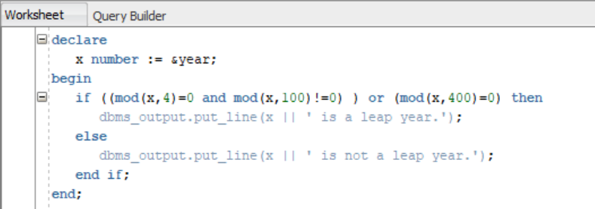

**Output:**

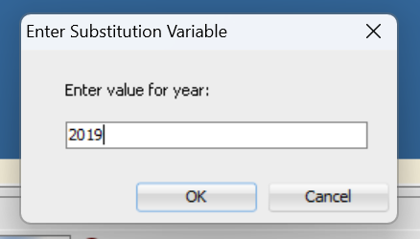

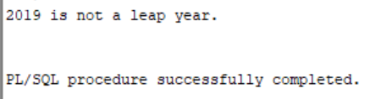

**PROGRAM- 2**

**TO** **FIND AREA AND CIRCUMFERENCE OF A CIRCLE USING A CASE STATEMENT.**

**Implementation:**

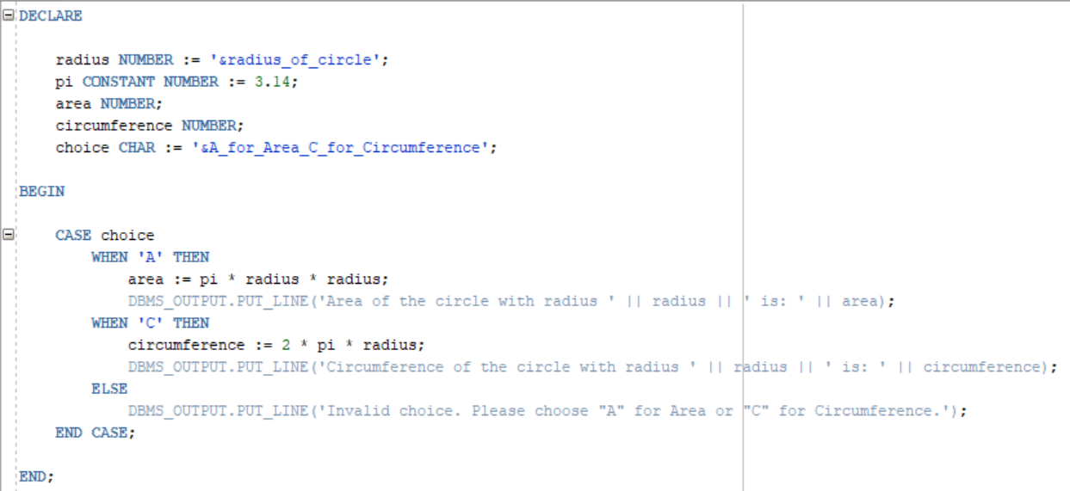

**Output:**

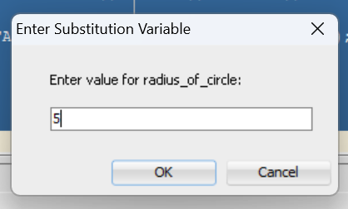 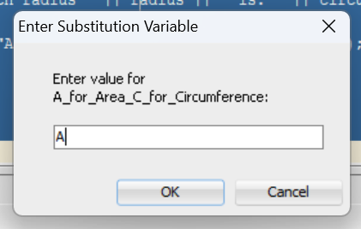

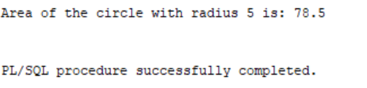

**PROGRAM- 3**

**TO CHECK WHETHER A PRIME NUMBER OR NOT USING WHILE LOOP AND FOR LOOP**

**Implementation:**

**A) WHILE LOOP**

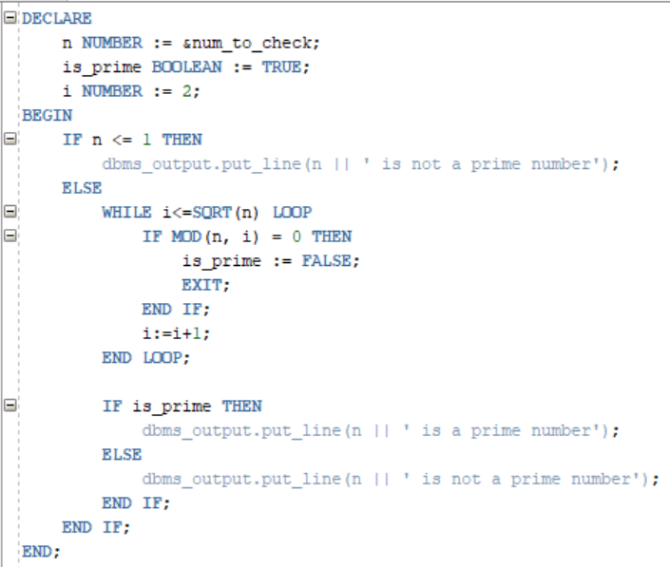

**B) FOR LOOP**

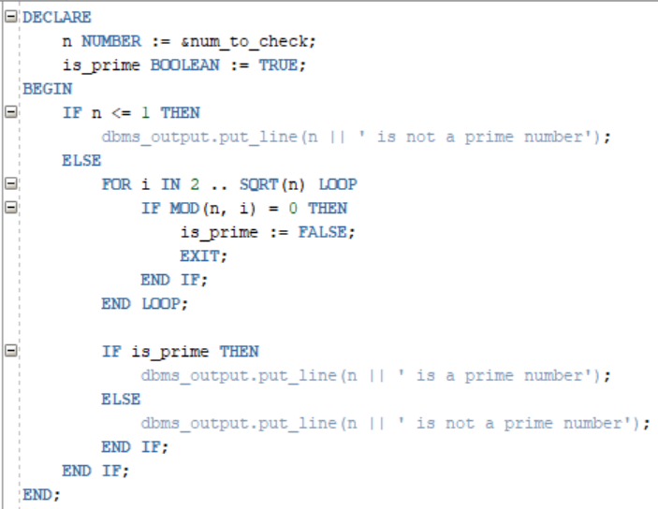

**Output:**

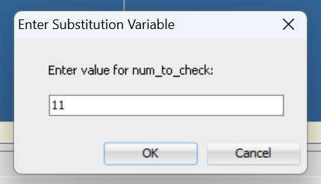

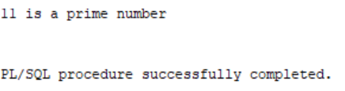

**PROGRAM- 4**

**TO GENERATE FIBONACCI SERIES**

**Implementation:**

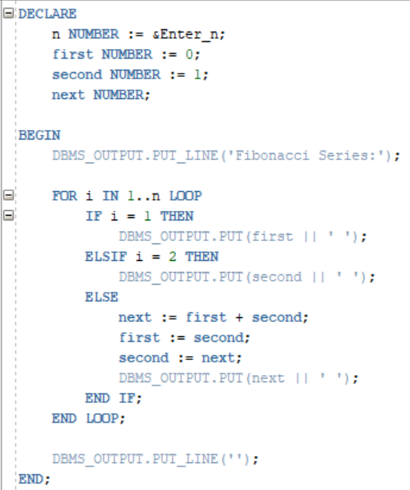

**Output:**

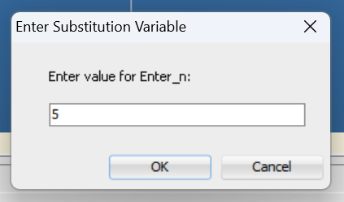

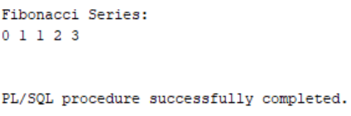

**PROGRAM- 5**

**TO GENERATE FACTORIAL OF A GIVEN NUMBER**

**Implementation:**

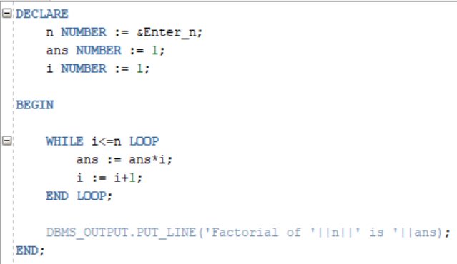

**Output:**

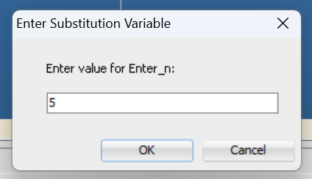

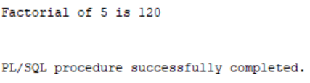

**PROGRAM- 6**

**TO CHECK PALINDROME**

**Implementation:**

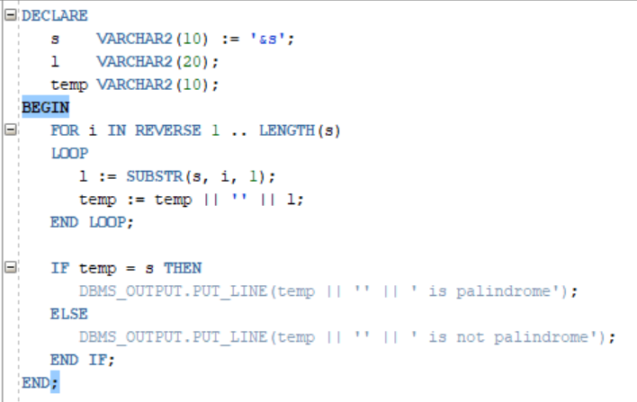

**Output:**

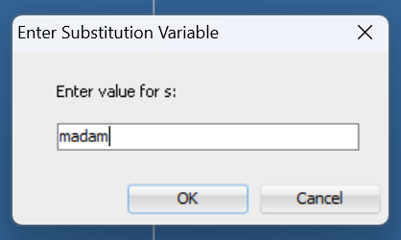

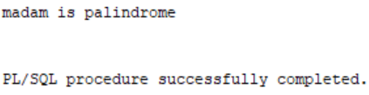

**PROGRAM- 7**

**TO** **CREATE A DUMMY CALCULATOR TAKING TWO NUMBERS AS INPUT AS PERFORMING SELECTED OPERATIONS(ADDITION,MULTIPLICATION,SUBTRACTION etc) AND DISPLAYING OUTPUT**

**Implementation:**

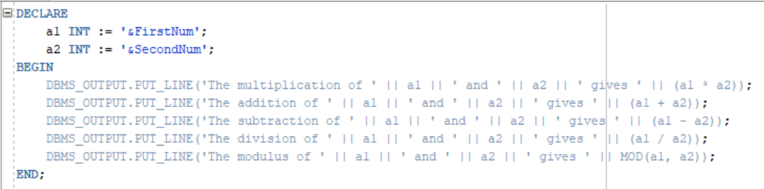

**Output:**

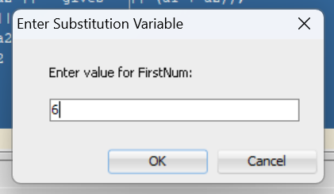 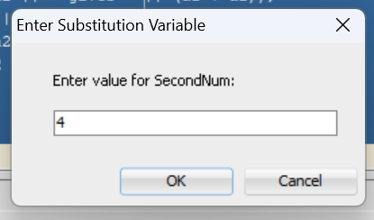

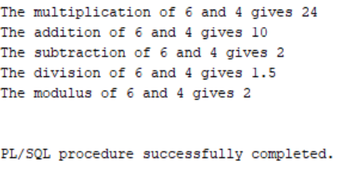

**PROGRAM- 7**

**TO** **CREATE A DUMMY CALCULATOR TAKING TWO NUMBERS AS INPUT AS PERFORMING SELECTED OPERATIONS(ADDITION,MULTIPLICATION,SUBTRACTION etc) AND DISPLAYING OUTPUT**

**Implementation:**



**Output:**

 



**Practical:- 12**

**SUBPROGRAMS IN PL/SQL**

* Subprogram is a part of Main program.
* A subprogram allows the decomposition of a main program into logical units called modules.
* By processing these modules, we will achieve the concept of modularization.
* PL/SQL programs refer to reusable program units that can be stored within the database as stored programs and can be executed whenever that program is required are called "SUBPROGRAMS".
* In PL/SQL, we refer to subprograms as named blocks and invoke them with a set of parameters.
* These subprograms/modules are divided into two types: 1) procedures and 2) functions.

1) [PROCEDURE](https://www.linkedin.com/feed/hashtag/procedure): Procedures are subprograms that perform a specific action or task. They can have input parameters, output parameters, or both. Procedures do not return a value directly.

2) [FUNCTIONS](https://www.linkedin.com/feed/hashtag/functions): Functions are subprograms that perform a specific task and return a value. They have input parameters and always return a value of a specified data type.

SQL is Structured Query Language, which is a computer language for storing,

manipulating and retrieving data stored in a relational database.

SQL is Structured Query Language, which is a computer language for storing,

manipulating and retrieving data stored in a relational database.

SQL is Structured Query Language, which is a computer language for storing,

manipulating and retrieving data stored in a relational database.

SQL is Structured Query Language, which is a computer language for storing,

manipulating and retrieving data stored in a relational database.

SQL is Structured Query Language, which is a computer language for storing,

manipulating and retrieving data stored in a relational database.

SQL is Structured Query Language, which is a computer language for storing,

manipulating and retrieving data stored in a relational database.

SQL is Structured Query Language, which is a computer language for storing,

manipulating and retrieving data stored in a relational database.

SQL is Structured Query Language, which is a computer language for storing,

manipulating and retrieving data stored in a relational database.

SQL is Structured Query Language, which is a computer language for storing,

manipulating and retrieving data stored in a relational database.

SQL is Structured Query Language, which is a computer language for storing,

manipulating and retrieving data stored in a relational database.

1. **INTRODUCTION TO PROCE DURES**

**SYNTAX for defining a PL/SQL Procedure:**

**CREATE OR** REPLACE**PROCEDURE** procedure_name (parameter1 datatype [**IN**|**OUT**|**IN OUT**], parameter2 datatype [**IN**|**OUT**|**IN OUT**], ...) **IS**

declaration1 datatype;

declaration2 datatype;

**BEGIN**

-- Executable statements

-- Code goes here

-- Exception handling

EXCEPTION

**WHEN** exception1 **THEN**

-- Exception handler for exception1

**WHEN** exception2 **THEN**

-- Exception handler for exception2

...

**WHEN** others **THEN**

-- Exception handler for all other exceptions

**END** procedure_name;

1. **INTRODUCTION TO FUNCTIONS**

**SYNTAX for defining a PL/SQL Function:**

**CREATE OR** REPLACE **FUNCTION** function_name (parameter1 datatype [**IN**|**OUT**|**IN OUT**], parameter2 datatype [IN|OUT|IN OUT], ...) **RETURN** return_datatype **IS**

**declaration1 datatype;**

**declaration2 datatype;**

**BEGIN**

-- Executable statements

-- Code goes here

-- Return statement (for functions)

**RETURN**return_value;

-- Exception handling

EXCEPTION

**WHEN** exception1 **THEN**

-- Exception handler for exception1

**WHEN** exception2 **THEN**

-- Exception handler for exception2

**...**

**WHEN** others **THEN**

-- Exception handler for all other exceptions

**END** function_name;

* **TO CHECK IF A YEAR IS A LEAP OR NOT.**

**PROCEDURE:**

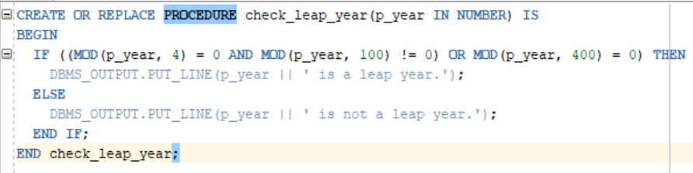

**FUNCTION:**

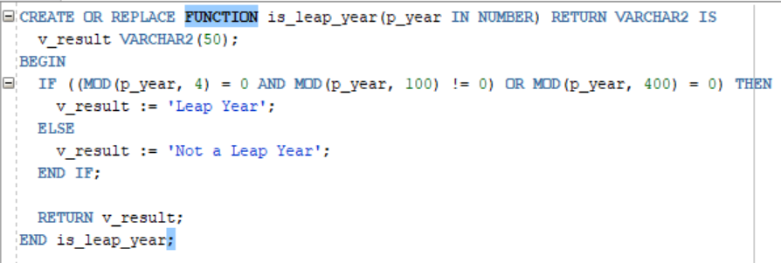

* **TO** **FIND AREA AND CIRCUMFERENCE OF A CIRCLE USING A CASE STATEMENT.**

**PROCEDURE:**

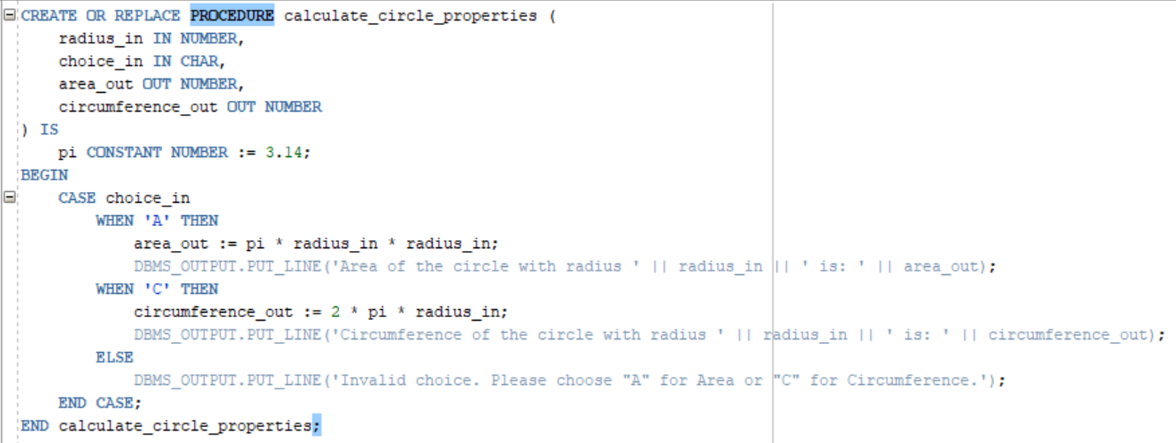

**FUNCTION:**

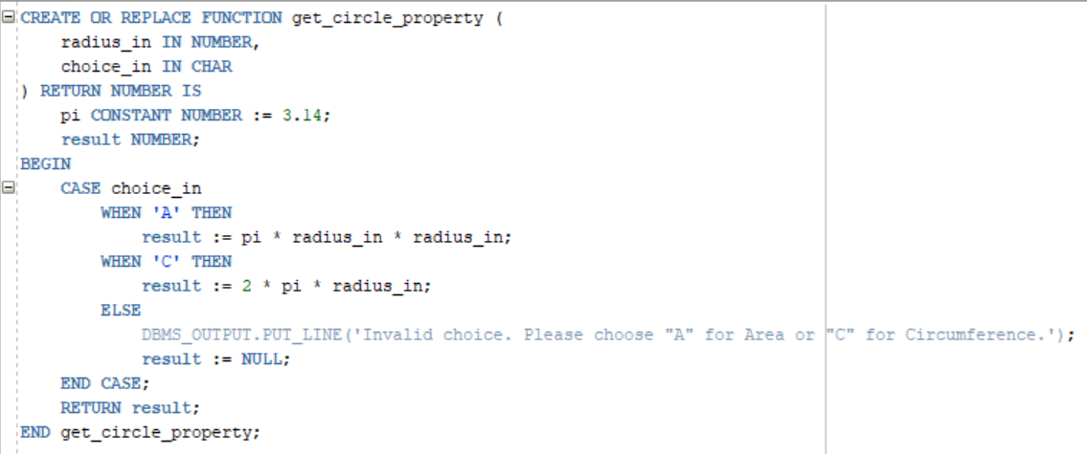

* **TO CHECK WHETHER A PRIME NUMBER OR NOT USING WHILE LOOP AND FOR LOOP**

**PROCEDURE:**

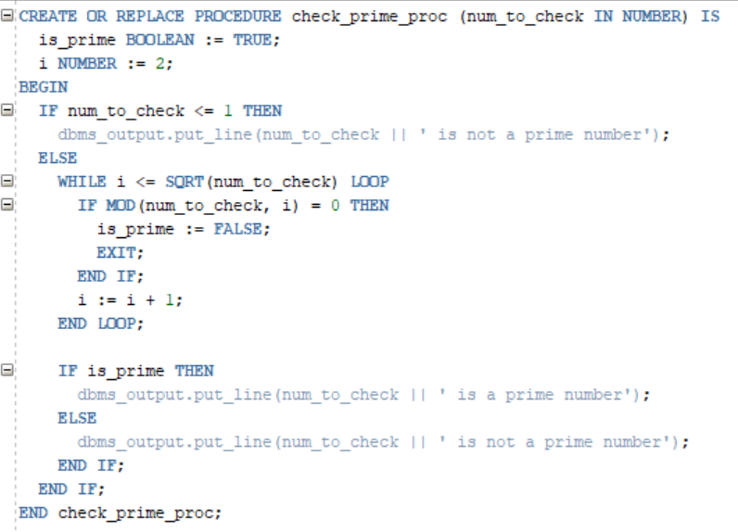

**FUNCTION:**

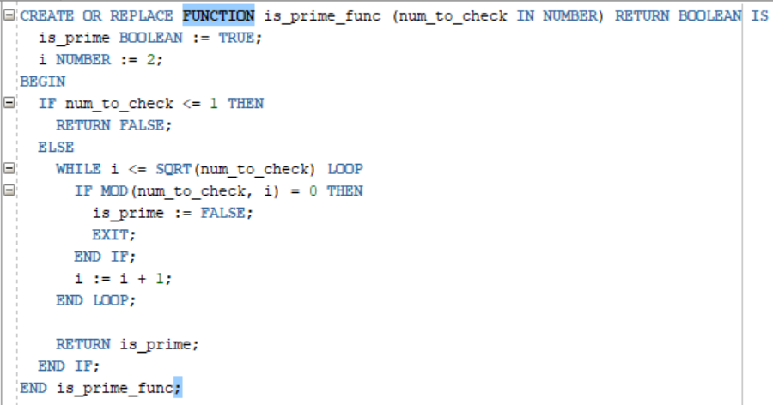

* **TO GENERATE FIBONACCI SERIES**

**PROCEDURE:**

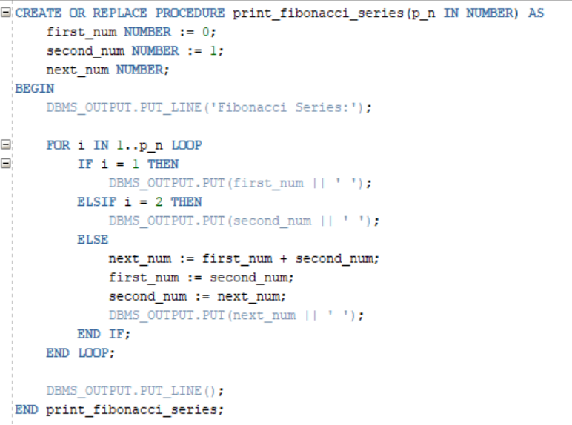

**FUNCTION:**

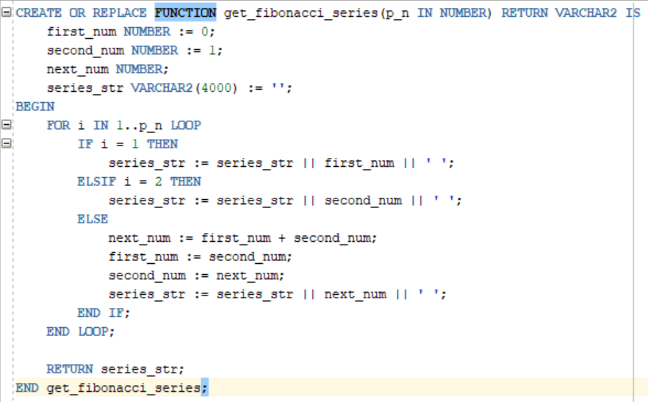

* **TO GENERATE FACTORIAL OF A GIVEN NUMBER.**

**PROCEDURE:**

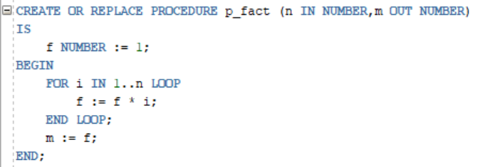

**FUNCTION:**

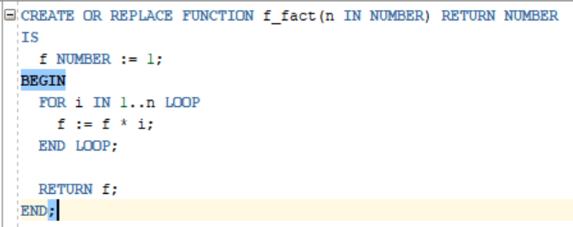

**Practical:- 13**

**TRIGGERS IN PL/SQL**

SQL is Structured Query Language, which is a computer language for storing,

manipulating and retrieving data stored in a relational database.

SQL is Structured Query Language, which is a computer language for storing,

manipulating and retrieving data stored in a relational database.

SQL is Structured Query Language, which is a computer language for storing,

manipulating and retrieving data stored in a relational database.

SQL is Structured Query Language, which is a computer language for storing,

manipulating and retrieving data stored in a relational database.

SQL is Structured Query Language, which is a computer language for storing,

manipulating and retrieving data stored in a relational database.

SQL is Structured Query Language, which is a computer language for storing,

manipulating and retrieving data stored in a relational database.

SQL is Structured Query Language, which is a computer language for storing,

manipulating and retrieving data stored in a relational database.

SQL is Structured Query Language, which is a computer language for storing,

manipulating and retrieving data stored in a relational database.

SQL is Structured Query Language, which is a computer language for storing,

manipulating and retrieving data stored in a relational database.

SQL is Structured Query Language, which is a computer language for storing,

manipulating and retrieving data stored in a relational database.

1. **INTRODUCTION TO PROCE DURES**

PL/SQL triggers are procedural code blocks or stored programs that are automatically executed or fired when some specific database events occur, such as insertions, updates, or deletions on a table. Triggers can be defined to run before or after the event occurs, allowing us to enforce business rules, maintain data integrity, or perform additional actions based on the event.

1. **ADVANTAGES AND DISADVANTAGES OF TRIGGERS**

**Advantages of using Triggers:**

* **Enforce data integrity and maintain consistency:** Triggers enable us to enforce data integrity by automatically performing validation checks or implementing business rules before or after data modifications. This helps maintain the consistency and accuracy of the data.
* **Automate actions and tasks based on events:** Triggers automate actions and tasks based on specific events or data modifications. They can automatically perform additional operations such as updating related tables, generating audit logs, or sending notifications. This reduces manual effort and ensures consistent actions.
* **Enhance security with access controls and restrictions:** Triggers can be used to enhance security by implementing access controls or restrictions. They allow us to perform authentication checks, enforce row-level security, or block unauthorized operations, improving data protection.
* **Promote code reusability for modular development:** Triggers can be reusable components that can be applied to multiple tables or events. This promotes code reusability, reduces code duplication, and simplifies maintenance efforts.
* **Maintaining consistency across related tables:** Triggers help maintain consistency across related tables by automatically updating or synchronizing data in response to modifications in one table. This ensures data integrity and eliminates the risk of inconsistencies.

**Disadvantages of using Triggers:**

* Hard to maintain since this may be a possibility that the new developer doesn’t able to know about the trigger defined in the database and wonder how data is inserted, deleted or updated automatically.
* They are hard to debug since they are difficult to view as compared to stored procedures, views, functions, etc.
* Excessive or over use of triggers can slow down the performance of the application since if we defined the triggers in many tables then they kept automatically executing every time data is inserted, deleted or updated in the tables (based on the trigger’s definition) and it makes the processing very slow.
* If complex code is written in the triggers, then it will slow down the performance of the applications.
* The cost of creation of triggers can be more on the tables on which frequency of DML (insert, delete and update)  operation like bulk insert is high.

1. **SYNTAX OF TRIGGERS**

**Syntax for creating a trigger:**

**CREATE** [OR REPLACE] **TRIGGER** trigger_name

{BEFORE | AFTER | INSTEAD OF} -- Trigger Timing

{INSERT | UPDATE | DELETE} -- Event

**ON** table_name

[FOR EACH ROW] -- Row Level

[ WHEN condition] -- conditional clause for trigger to get execute

**DECLARE**

  -- Declaration section for variables, constants, etc.

**BEGIN**

  -- Trigger logic and executable statements

**EXCEPTION**

  -- Exception handling statements

**END;**

The **WHEN** condition is an optional clause that allows us to specify a condition that must evaluate to true for the trigger to be executed. This condition can include comparisons, logical operators, and other expressions.

With this syntax, we can create a trigger that is triggered before or after an insert, update, or delete operation on a specific table. The trigger can be defined to execute for each affected row using the **FOR EACH ROW** clause. We can also include a **WHEN** condition to further filter when the trigger should be executed.

Inside the trigger, we can declare variables, constants, and other declarations in the declaration section. The trigger logic and executable statements are placed between the **BEGIN** and **END;** block. Exception handling statements can be included to handle any exceptions that may occur during the trigger execution.

old and :new are pseudorecords referred to access row level data when using row level trigger:

**:old -**refers to OLD VALUE

**:new -**refers to NEW VALUE

For Below operation, respective old and new values:

1. **INSERT-** :old.value= NULL, :new value= post insert value
2. **DELETE-** :old.value= Pre Delete value, :new value= null
3. **UPDATE-** :old.value= Pre update value, :new value= Post Update value
4. **TYPES OF TRIGGERS**

Triggers can be classified based on the following parameters:

**Classification based on the timing of their execution in relation to the triggering event:**

1. **Before Triggers:** These triggers are executed before the triggering event occurs. They are commonly used for data validation or modification before the actual operation takes place. Before triggers can be used with INSERT, UPDATE, and DELETE statements.
2. **After Triggers:** After triggers are executed after the triggering event completes. They are often used for auditing, logging, or performing additional actions based on the outcome of the triggering event. After triggers can be used with INSERT, UPDATE, DELETE, and SELECT statements.
3. **Instead of Triggers:** Instead of triggers are primarily used with views. These triggers are the special type of trigger. It is used only in DML triggers. It is used when any DML event is going to occur on the complex view.

**Classification based on the Level:**

1. **Row level Triggers:** Row-level triggers are executed once for each row affected by the triggering event. They can access and modify column values using the **:NEW** and **:OLD** qualifiers. Row-level triggers are specified using the **FOR EACH ROW** clause. (only for DML)
2. **Statement level Triggers:** Statement-level triggers are executed once for each triggering event, regardless of the number of rows affected. They cannot access or modify individual column values. Statement-level triggers do not include the **FOR EACH ROW** clause.

**Classification based on the Event:**

1. **DML Triggers:** These triggers are fired in response to Data Manipulation Language (DML) statements such as **INSERT, UPDATE,** and **DELETE.** They allow us to perform actions before or after the data modification occurs.
2. **DDL Triggers:** DDL triggers are triggered by Data Definition Language (DDL) statements, which are used to **CREATE, ALTER,**or**DROP** database objects such as tables, views, or procedures. DDL triggers enable us to enforce data integrity rules or perform administrative tasks.
3. **Database Triggers**: Database triggers are associated with specific database-wide events, such as **STARTUP** or **SHUTDOWN** of the database, **LOGON**or**LOGOFF** of a user, or errors occurring in the database. They provide the ability to respond to these events and take appropriate actions.
4. **System Triggers:** System triggers are executed when certain system-level events occur, such as a server error, a change in database configuration, or resource-related events. They allow us to handle system-specific events and implement custom logic.
5. **WRITE PROGRAMS TO DEMONSTRATE ALL TYPES OF TRIGGER GIVEN IN D ON DATABASE CREATED IN PRACTICAL 1**

* **Before Event Triggers**

**Implementation:**

4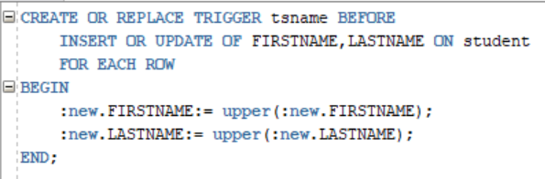



**Output:**

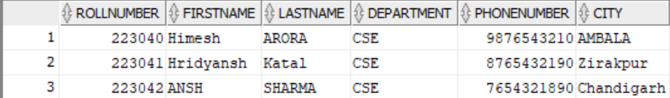

* **After Event Triggers**

**Implementation:**

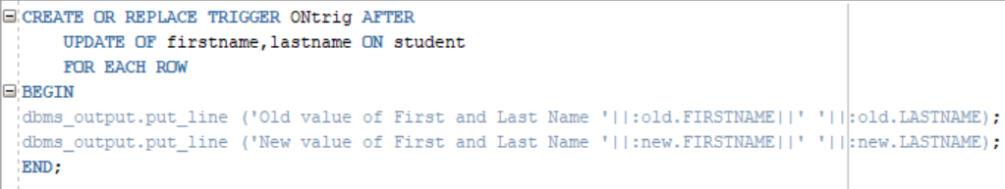

**Output:**

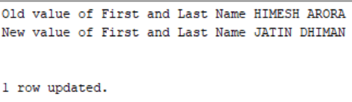

* **Row Trigger**

**Implementation:**



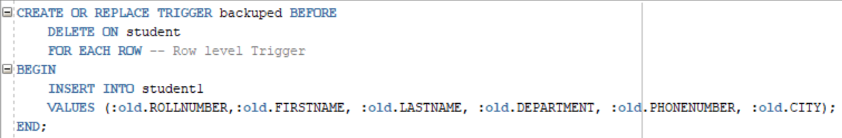



**Output:**

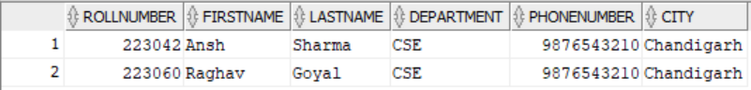

1. **IMPLEMENT AUDIT TRAIL TO KEEP RECORD OF EVERY INSERT, UPDATE, DELETE ON ABOVE DATABASE, IT SHOULD STORE NAME OF THE USER, OPERATION PERFORMED AND TIME OF THE OPERATION**

* Create a log Table to keep the track of the various Operation performed in the Database.

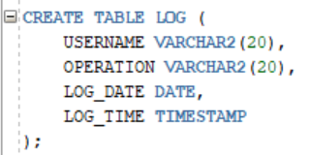

* Create a Statement level trigger

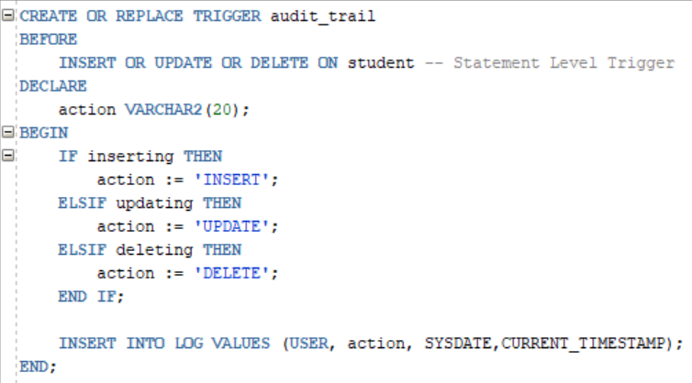

* Insert into the Student Table

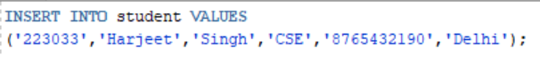

* Log Table after the Operation

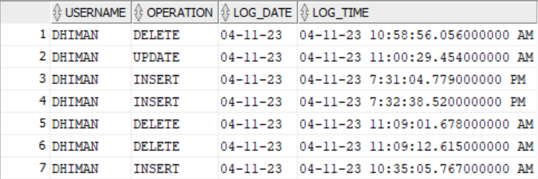

**NOTE:**

We can Create Multiple Users and do Operations ON the database to Reflect on th Log table

**Practical:- 14**

**CURSORS IN PL/SQL**

SQL is Structured Query Language, which is a computer language for storing,

manipulating and retrieving data stored in a relational database.

SQL is Structured Query Language, which is a computer language for storing,

manipulating and retrieving data stored in a relational database.

SQL is Structured Query Language, which is a computer language for storing,

manipulating and retrieving data stored in a relational database.

SQL is Structured Query Language, which is a computer language for storing,

manipulating and retrieving data stored in a relational database.

SQL is Structured Query Language, which is a computer language for storing,

manipulating and retrieving data stored in a relational database.

SQL is Structured Query Language, which is a computer language for storing,

manipulating and retrieving data stored in a relational database.

SQL is Structured Query Language, which is a computer language for storing,

manipulating and retrieving data stored in a relational database.

SQL is Structured Query Language, which is a computer language for storing,

manipulating and retrieving data stored in a relational database.

SQL is Structured Query Language, which is a computer language for storing,

manipulating and retrieving data stored in a relational database.

SQL is Structured Query Language, which is a computer language for storing,

manipulating and retrieving data stored in a relational database.

1. **INTRODUCTION**

* Whenever SQL statement processed, Oracle creates a memory area which is known as "**Context Area**".
* Cursor is the pointer to that context Area.
* A Cursor is a temporary work area created in the system memory when a SQL statement is executed.
* A cursor contains all the information which is needed to process the SQL statement, specifically SELECT statement and the rows of data accessed by that statement.
* This temporary work area is used to store the data, retrieved from the database, and manipulate this data.
* A cursor can hold more than one row, but can process only one row at a time. The set of rows the cursor holds is called the "**Active Set"**.
* The primary role of a cursor in PL/SQL is to provide a way to iterate through the result set returned by a SELECT statement. It enables us to perform operations on each row of the result set sequentially, rather than retrieving all the data at once. This can be particularly useful when dealing with large datasets or when we need to perform complex data manipulation.
* In short: A cursor is a temporary memory area which creates a buffer that holds the data we selected.

1. **ADVANTAGES AND DISADVANTAGES OF CURSOR**

**Advantages of using Cursor:**

* Using Cursor we can perform row by row processing so we can perform row wise validation or operations on each row.
* Cursors can provide the first few rows before the whole result set is assembled. Without using cursors, the entire result set must be delivered before any rows are displayed by the application. So using cursor, better response time is achieved.
* If we make updates to our without using cursors in your application then we must send separate SQL statements to the database server to apply the changes. This can cause the possibility of concurrency problems if the result set has changed since it was queried by the client. In turn, this raises the possibility of lost updates. So using cursor, better concurrency Control can be achieved.
* Cursors can be faster than a while loop but at the cost of more overhead.

**Disadvantages of using Cursor:**

* Cursor in SQL is temporary work area created in the system memory, thus it occupies memory from your system that may be available for other processes. So occupies more resources and temporary storage.
* Each time when a row is fetched from the cursor it may result in a network round trip. This uses much more network bandwidth than the execution of a single SQL statement like SELECT or DELETE etc that makes only one round trip.
* Repeated network round trips can degrade the speed of the operation using the cursor.

1. **TYPES OF CURSORS: IMPLICIT AND EXPLICIT CURSORS**

There are two types of cursors in PL/SQL:

1. PL/SQL Implicit Cursors
2. PL/SQL Explicit Cursors
3. [**IMPLICIT CURSORS**](https://www.linkedin.com/feed/hashtag/implicit_cursors)**:**

* The implicit Cursors are automatically generated by Oracle while an SQL statement is executed, if we don't use an explicit cursor for the statement. These are created by default to process the statement like DML statements like INSERT, UPDATE, DELETE etc, are executed. Oracle provides some attributes known as **Implicit cursor's attributes** to check the status of DML operations. Some of the Attributes are:

**1) Attribute: %FOUND**

Its return value is TRUE, if DML statements like INSERT, DELETE and UPDATE affect at least one row or more rows or a SELECT INTO statement returned one or more rows. Otherwise, it returns FALSE.

**2) Attribute: %NOT FOUND**

Its return value is TRUE, if DML statements like INSERT, DELETE and UPDATE affect no row, or a SELECT INTO statement return no rows. Otherwise, it return FALSE. It is a just opposite of %FOUND.

**3) Attribute: %ISOPEN**

It always returns FALSE for implicit cursors, because the SQL cursor is automatically closed after executing its associated SQL statements.

**4) Attribute: %ROWCOUNT**

It returns the number of rows affected by DML statements like INSERT, DELETE and UPDATE or returned by SELECT INTO statement.

1. [**EXPLICIT CURSORS**](https://www.linkedin.com/feed/hashtag/explicit_cursors)**:**

* The explicit cursors are defined by the programmers to gain more control over the context area. These courses should be defined in the declaration section of the PL/SQL block. It is created on a select statement which returns more than the one row.

**1)** **DECLARE**

**2) OPEN**

**3) FETCH**

**EMPTY**(if NO (it means still there are some rows to fetch) ---> Again goes to FETCH block, if YES (when we get all the rows, it means there are no rows to fetch) ---> It goes to the Close block)

**4) CLOSE**

**STEPS WHILE WORKING WITH AN EXPLICIT CURSOR**

1. Declare the cursor to initialize in the memory.
2. Open the cursor to allocate the memory.
3. Fetch the cursor to retrieve data.
4. Close the cursor to release allocated memory.

[DECLARE THE CURSOR](https://www.linkedin.com/feed/hashtag/declare_the_cursor): To use a cursor, we first need to declare it. This involves defining its name, the SQL statement it will execute, and any associated parameters. For example:

**Syntax:**

**CURSOR** cursor_name **IS**

**SELECT** column1, column2, ...

**FROM** table_name

**WHERE** condition;

[OPEN THE CURSOR](https://www.linkedin.com/feed/hashtag/open_the_cursor): Once we have declared a cursor, we need to open it before fetching data. This is done using the **OPEN** statement. It establishes a connection between the cursor and the result set. It is used to allocate memory for the cursor and make it easy to fetch the rows returned by the SQL statements into it. For example:

**Syntax: OPEN**cursor_name;

[FETCH THE CURSOR](https://www.linkedin.com/feed/hashtag/fetch_the_cursor): After opening the cursor, we can fetch rows from the result set one at a time. This is typically done using a loop construct. The **FETCH** statement retrieves the next row and moves the cursor to the subsequent position. For example:

**Syntax:** **FETCH** cursor_name **INTO**variable1, variable2, ...;

Inside the loop, we can perform operations on the fetched row using the assigned variables.

[CLOSE THE CURSOR](https://www.linkedin.com/feed/hashtag/close_the_cursor): Once we have finished processing the result set, we need to close the cursor to release any associated resources. This is done using the **CLOSE** statement. For example:

**Syntax:** **CLOSE** cursor_name;

**PROGRAM**

**TO COUNT THE NUMBER OF RECORDS USING AN IMPLICIT CURSOR.**

**Implementation:**

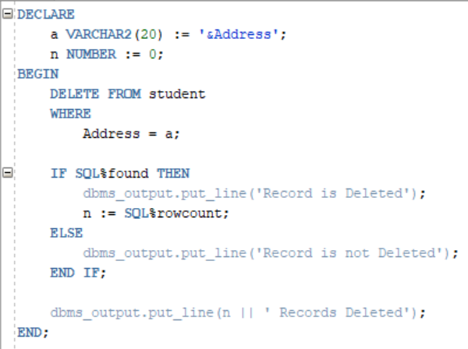

**Output:**

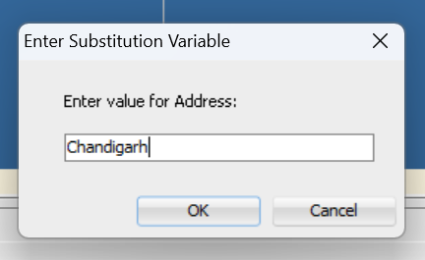

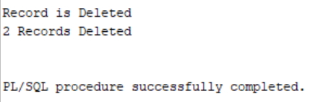

**PROGRAM**

**TO DISPLAY RECORDS OF 5 LEAST PAID EMPLOYEES USING EXPLICIT CURSOR.**

**Implementation:**

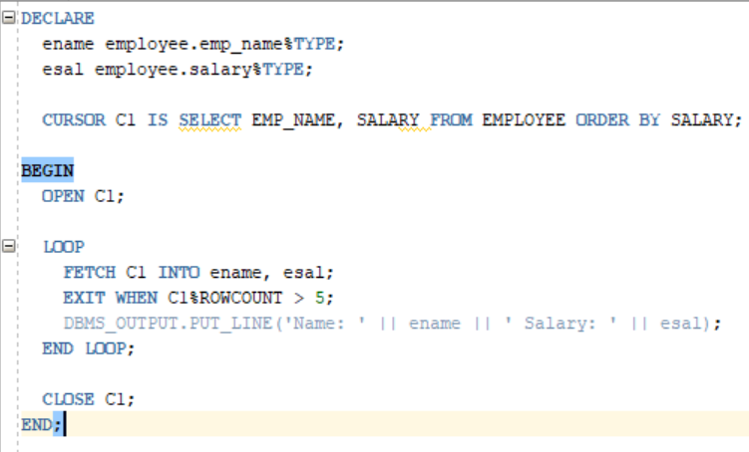

**Output:**

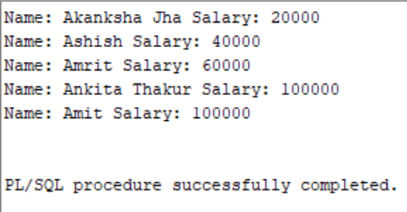

**PROGRAM**

**TO DISPLAY RECORDS OF 5 HIGHEST PAID EMPLOYEES USING EXPLICIT CURSOR.**

**Implementation:**

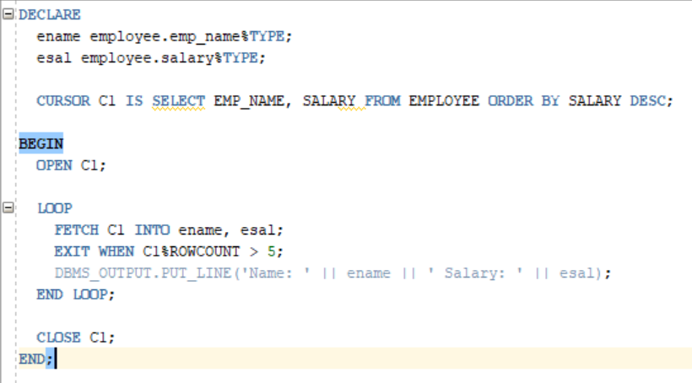

**Output:**

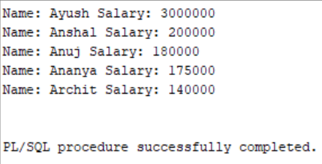

**PROGRAMS**

**TO DISPLAY FUNCTIONALITY OF %TYPE, %ROWTYPE**

**Implementation:**

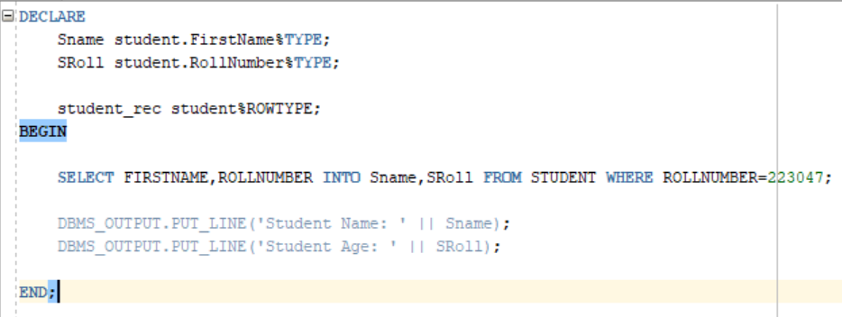

**Output:**

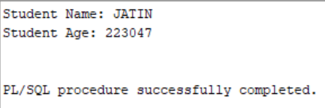

**PROGRAMS**

**CREATE IMPLICIT AND EXPLICIT CURSOR TO DEMONSTRATE FUNCTIONALITY OF ALL 4 ATTRIBUTES FOR PRACTICAL 1 DATABASE**

**IMPLICIT CURSORS**

* **%found**

**Implementation:**

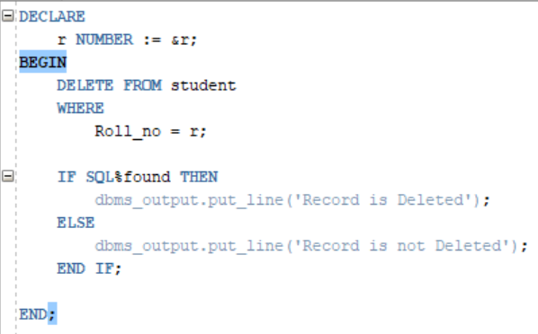

**Output:**

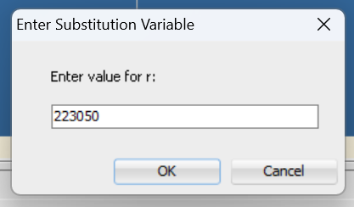

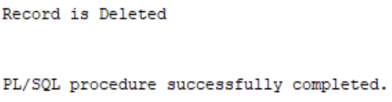

* **%notfound**

**Implementation:**

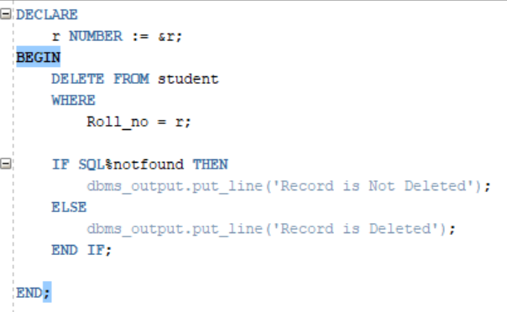

**Output:**





* **%isOpen**

**Implementation:**

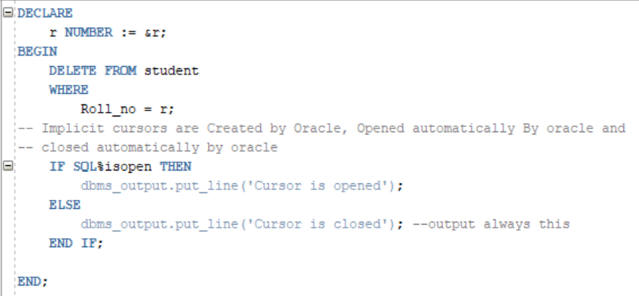

**Output:**



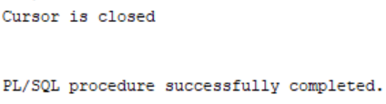

* **%rowCount**

**Implementation:**

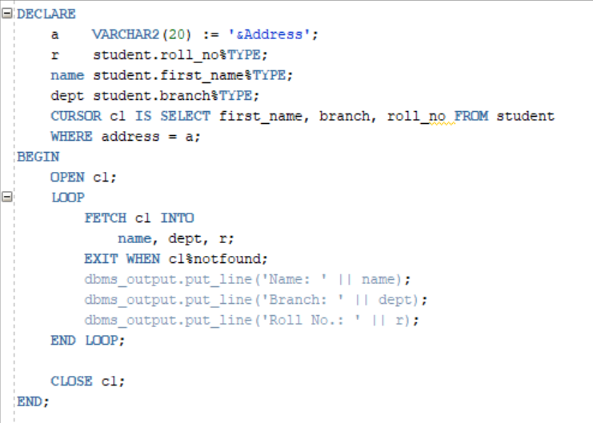

**Output:**



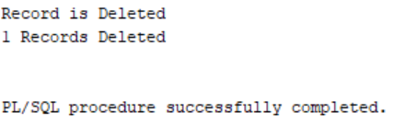

**EXPLICIT CURSOR**

**Implementation:**



**Output:**



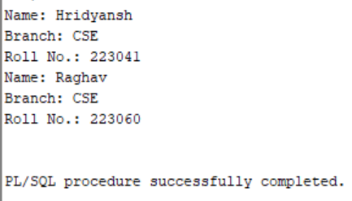

**Practical:- 14**

**PACKAGES IN PL/SQL**

SQL is Structured Query Language, which is a computer language for storing,

manipulating and retrieving data stored in a relational database.

SQL is Structured Query Language, which is a computer language for storing,

manipulating and retrieving data stored in a relational database.

SQL is Structured Query Language, which is a computer language for storing,

manipulating and retrieving data stored in a relational database.

SQL is Structured Query Language, which is a computer language for storing,

manipulating and retrieving data stored in a relational database.

SQL is Structured Query Language, which is a computer language for storing,

manipulating and retrieving data stored in a relational database.

SQL is Structured Query Language, which is a computer language for storing,

manipulating and retrieving data stored in a relational database.

SQL is Structured Query Language, which is a computer language for storing,

manipulating and retrieving data stored in a relational database.

SQL is Structured Query Language, which is a computer language for storing,

manipulating and retrieving data stored in a relational database.

SQL is Structured Query Language, which is a computer language for storing,

manipulating and retrieving data stored in a relational database.

SQL is Structured Query Language, which is a computer language for storing,

manipulating and retrieving data stored in a relational database.

1. **INTRODUCTION TO PACKAGE**

* Packages are the Stored libraries in the Database which allow us to group related related PL/SQL objects under one name
* Packages are the Logical groups of related PL/SQL Objects.
* Packages are named PL/SQL Blocks,Permanently Stored in the database Schema can be referenced or reused by your program
* We can include Following things in the package
* Stored Procedures
* PL/SQL Functions
* Database Cursors
* Type Declarations
* Variables

1. **PACKAGE BODY**

* In this Section We put the Declaration of all the Package Elements
* Whatever elements we Declare here in this Section are Publically available and can be referred outside of the Package

**Syntax:**

CREATE OR REPLACE PACKAGE pkg_name

(IS/AS)

BEGIN

FUNCTION func_name (list of arguments) RETURN data type;

PROCEDURE proc_name (list of arguments)

END pkg_name;

1. **PACKAGE SPECIFICATION**

* In Package Body we provide the actual Structure to all the package elements
* A package body contains the implementation of the elements listed in the package specification.
* A Package body can contain both the declaration of the variable as well as the definition of all the package elements
* Any Package elements which is not in the package specification but coded in the package body is called “**Private Package Elements”.**

**Syntax:**

CREATE OR REPLACE PACKAGE pkg_name

(IS/AS)

FUNCTION func_name (list of arguments) RETURN data type;

(IS/AS)

[Local declarations of function]

BEGIN

EXCEPTIONS

END func_name;

PROCEDURE proc_name (list of arguments)

(IS/AS)

[Local declarations of function]

BEGIN

EXCEPTIONS

END proc_name;

END pkg_name;

1. **ADVANTAGES AND DISADVANTAGES**

* .

1. **CREATE PACKAGE OF CIRCLE AREA AND CIRCUMFERENCE**

* Package Specification

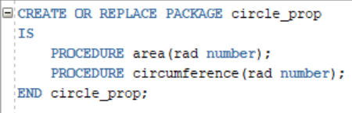

* Package Body

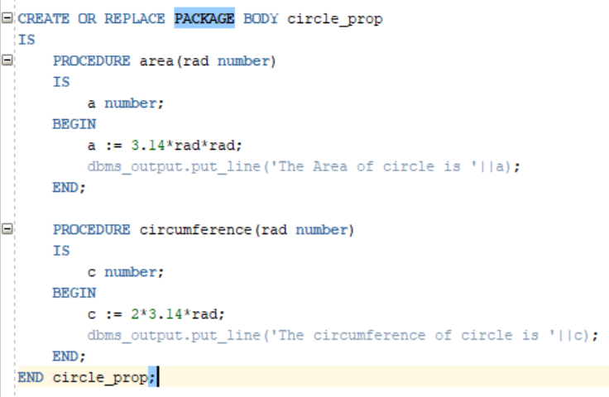

* Executing Package

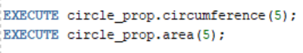

* Output

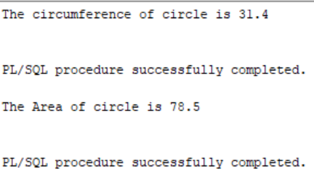

1. **PROGRAM: CREATE COMPLETE PACKAGE FOR EMPLOYEE MANAGEMENT SYSTEM TO DEMONSTRATE INSERT, UPDATE, DELETE , SEARCH(BY NAME, ID), DIPLAY, CALCULATE SALARY, INCREASE SALARY, PROMOTE, DEMOTE EMPLOYEE RECORDS**

* Package Specification

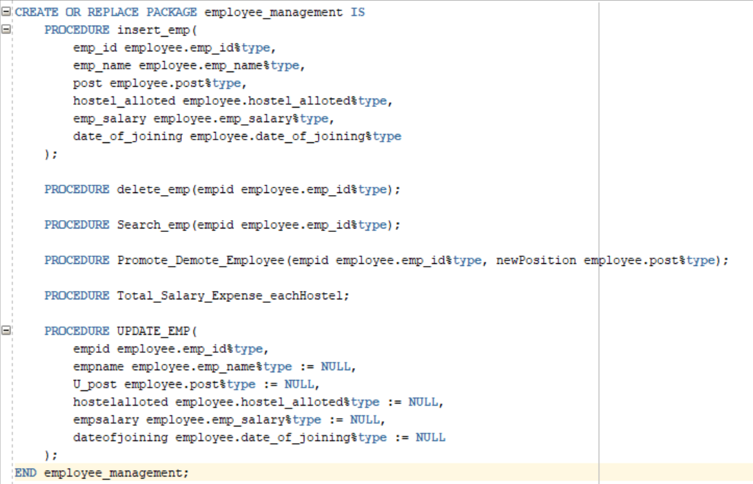

* Package Body

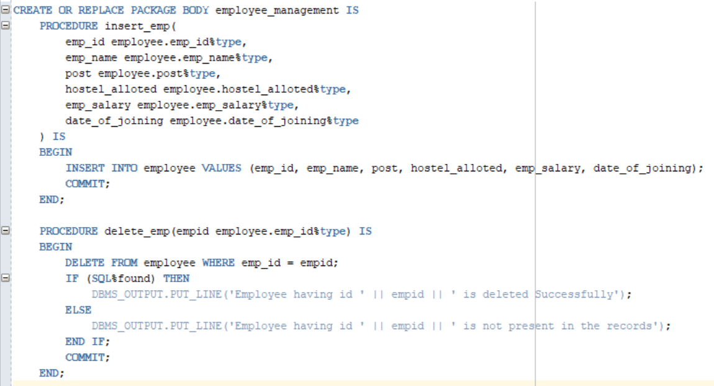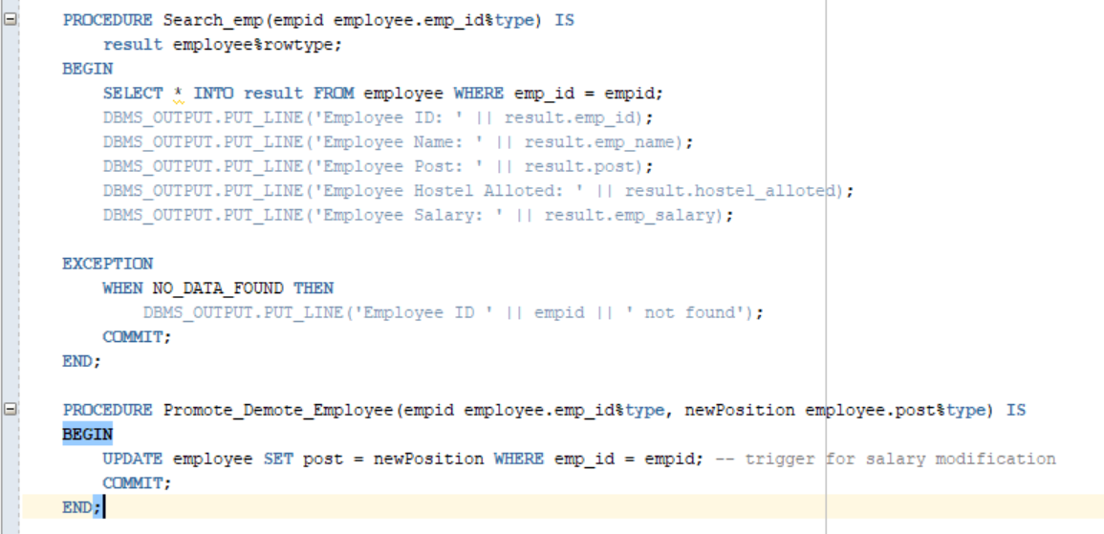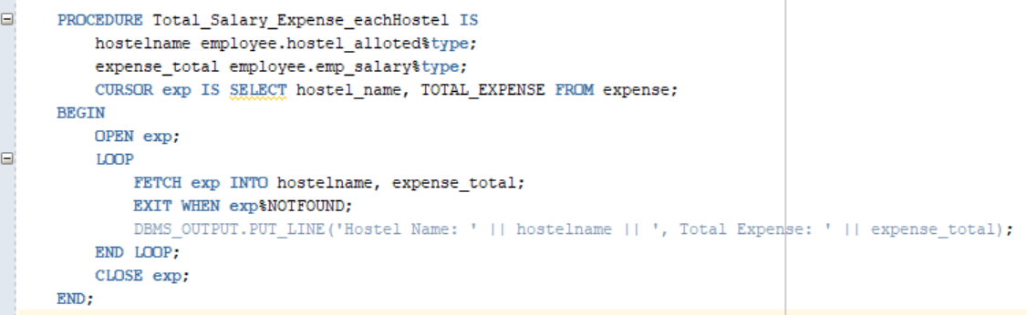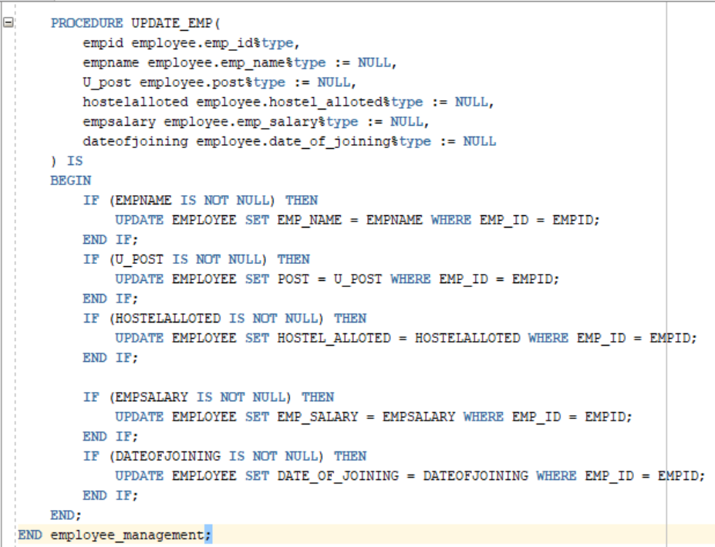

* Executing Package

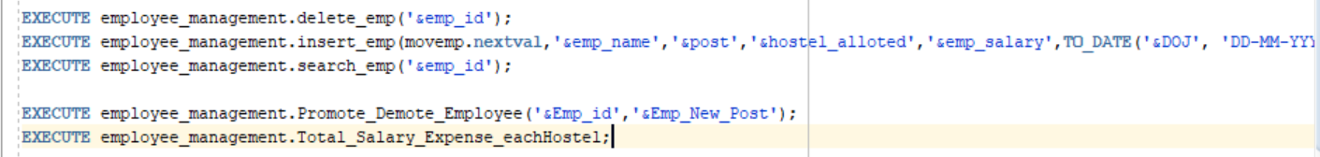

* Trigger and view Used

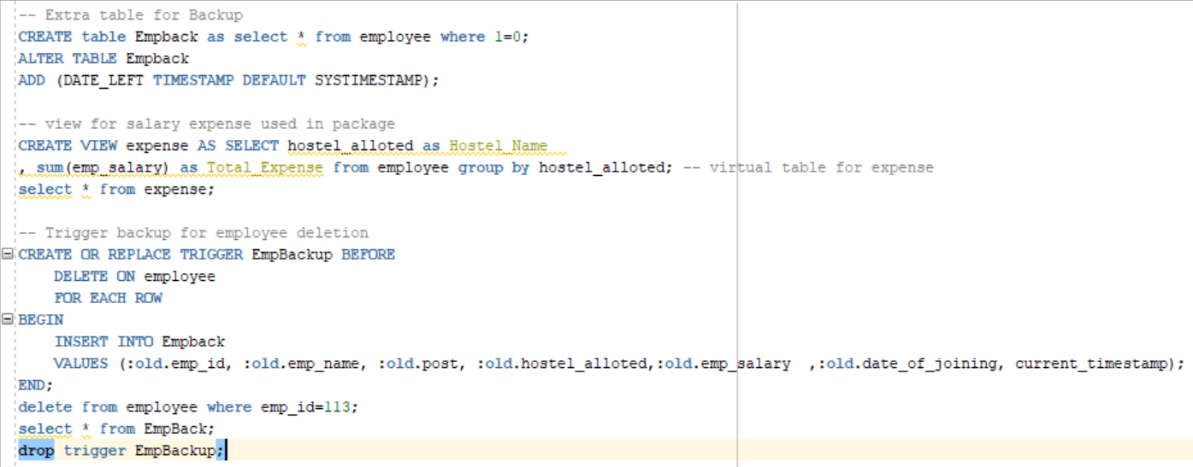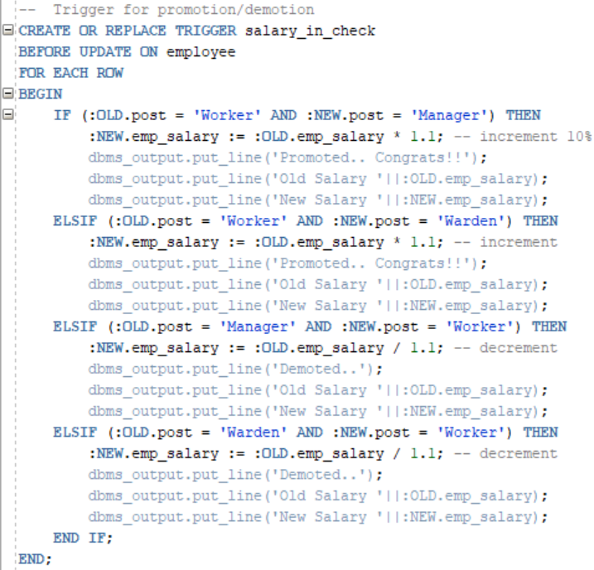

**QUERY 1:**

**GIVE THE TOTAL SALARY ISSUED BY EACH DEPARTMENT**

**Implementation:**

Using natural join



Using inner join



Using cross product



**Output:**

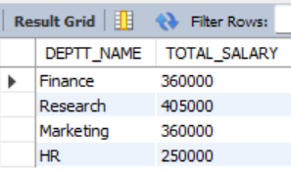

**QUERY 2:**

**AVERAGE SALARY OF EACH JOB**

**Implementation:**



**Output:**

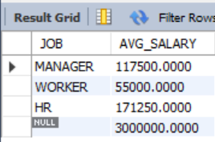

**QUERY 3:**

**GIVE THE TOTAL SALARY PAID TO EACH JOB WITHIN EACH DEPARTMENT**

**Implementation:**

Using natural join



Using inner join



Using Cross Product



**Output:**

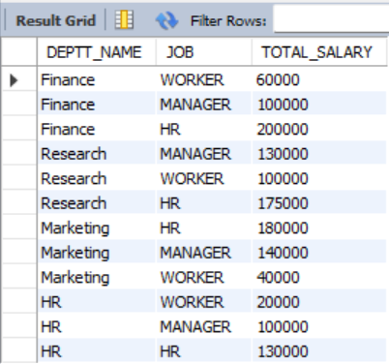

**QUERY 4:**

**GIVE TOTAL,MINIMUM,MAXIMUM AND AVERAGE SALARY OF EMPLOYEES JOBWISE FOR DEPARTMENT NUMBERS 1 AND 2 AND DISPLAYING ROWS HAVING AVERAGE SALARY> 1,00,000**

**Implementation:**



**Output:**

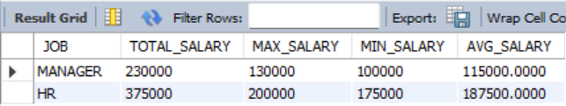

**QUERY 5:**

**GIVE NAME,SALARY OF THE EMPLOYEE HAVING SALARY GREATER THAN MINIMUM SALARY OF DEPARTMENT ‘RESEARCH’**

**Implementation:**

Using natural join



Using inner join



Using cross product



**Output:**

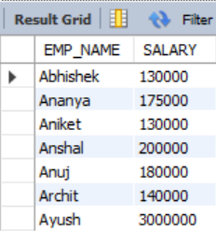

**QUERY 6:**

**GIVE NAME,SALARY OF THE EMPLOYEE HAVING SALARY GREATER THAN AVERAGE SALARY OF DEPARTMENT ‘HR’**

**Implementation:**

Using natural join



Using inner join



Using cross product



**Output:**

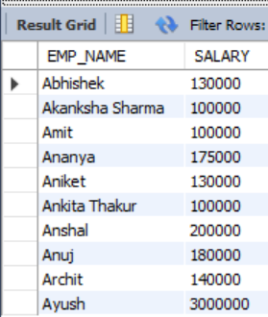

**QUERY 7:**

**LIST ALL THE DETAILS OF THE DEPARTMENT WHOSE MANAGERID= ‘E006’**

**Implementation:**

Using natural join

Using inner join

Using cross product

**Output:**

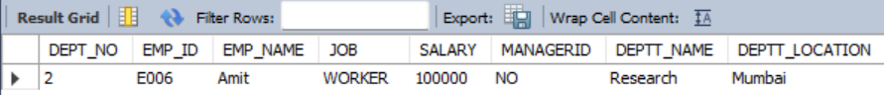

**QUERY 8:**

**LIST ALL EMPLOYEES BELONGING TO DEPARTMENT FINANCE**

**Implementation:**

Using natural join



Using inner join

Using cross product

**Output:**

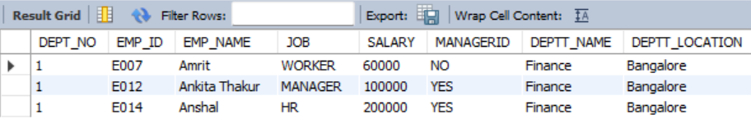

**QUERY 9:**

**LIST NAME OF EMPLOYEES WHO DO THE SAME JOBS THAT OF EMPLOYEE HAVING EMPLOYEE ID= ‘E008’**

**Implementation:**

­­­­­



**Output:**

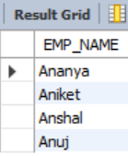

**QUERY 10:**

**LIST NAME OF EMPLOYEES WHO DO THE SAME JOBS THAT OF EMPLOYEE HAVING EMPLOYEE ID= ‘E012’ AND GET THE SALARY GREATER THAN THE SALARY OF THAT EMPLOYEE.**

**Implementation:**



**Output:**

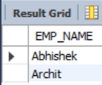

**QUERY 11:**

**LIST THE NAME AND SALARY OF EMPLOYEES WHO EARN MORE THAN THE DEPARTMENT OF ‘RESEARCH’.**

**Implementation:**



**Output:**

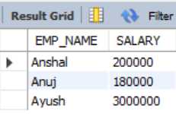

**QUERY 12:**

**LIST THE NAME OF EMPLOYEES WHO DONOT MANAGE ANY EMPLOYEE**

**Implementation:**



**Output:**

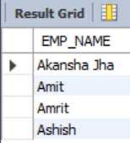

**QUERY 13:**

**LIST THE NAME OF EMPLOYEES WHO HAVE ATLEAST ONE PERSON REPORTING TO THEM**

**Implementation:**



**Output:**

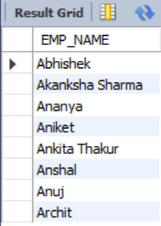

**QUERY 14:**

**GIVE THE NAME OF EMPLOYEES HAVING SALARY**

**A) LESS THAN MINIMUM OF SALARY OF ‘HR’ DEPARTMENT AND ARE NOT OF ‘HR’ DEPARTMENT**

**B) GREATER THAN MINIMUM OF SALARY OF ‘HR’ DEPARTMENT AND ARE NOT OF ‘HR’ DEPARTMENT**

**Implementation:**

First part



Second part



**Output:**

First part

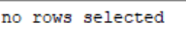

Second part

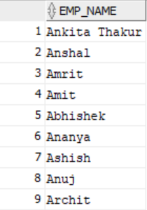

**QUERY 15:**

**LIST THE NAME OF HIGHEST PAID EMPLOYEE**

**Implementation:**









**Output:**

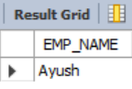

**QUERY 16:**

**LIST THE NAME OF LOWEST PAID EMPLOYEE.**

**Implementation:**









**Output:**

